

1401_03 - Run PO SMD - on maker-packer based on MC messages

Process Definition Document (PDD)

**Document History**

| Date | Version | Role | Name | Organization | Function | Comments |
| --- | --- | --- | --- | --- | --- | --- |
| 19.11.2019 | 1.0 | Author | K.NIROSH | ITC Infotech |  | PDD V1.0 |
|  |  |  |  |  |  |  |
|  |  |  |  |  |  |  |

**Contents**

**1** **Process key contacts 4**

**2** **Minimum Pre-requisites for automation 4**

2.1 Pre-requisites……………………………………………………………………………………………………………………4

**3 Test Cases (Scenario link from Teams)…………………………………………………………….4**

# 4 Components not in Scope (External System Components)…………………………...…4

**5** **Data To be used……………………………………………………………………………………………5**

# 6 As Is Process Description………………………………………………………………..5

6.1 As Is Process Overview 6

# 7 To Be Process Description

7.1 To Be Detailed Process Map 7

7.2 Deviations / Technical decision taken for automation 8

**8** **In Scope for Automation 9**

**8** **Out of Scope for Automation 9**

**9** **Business Exceptions Handling 9**

9.1 Known Exceptions 10

9.2 Unknown Exceptions9

9.3 Automation Exceptions…………………………………………………………………………………………………….10

**10** **Document Approval 10**

**11** **Screenshots of Manual Execution : 11**

**12 APPENDIX**

# Process key contacts

| Role | Name | Contact details  (email, phone number) | Notes |
| --- | --- | --- | --- |
| Manual Flow Execution | K.NIROSH | knirosh@itcinfotech.com |  |
| Test Architect | Sonai Layek | [Sonai.Layek@itcinfotech.com](mailto:Sonai.Layek@itcinfotech.com) |  |
| Automation Tester | K.NIROSH | knirosh@itcinfotech.com |  |

# Minimum Pre-requisites for automation

| S. No | Application name & version | Type | Test Data Required |
| --- | --- | --- | --- |
| 1 | Delmia Apriso 2019 Desktop Client | Desktop  Application | Username, Password |
| 2 | SOAP UI | API | Master Case XML |

## Pre-requisites



# Test Cases (Scenario link from Teams)

Find attached Excel



# Components not in Scope (External System Components)

1. ECC_CO03_ITF_Check PO status
2. MFG_CPV_HH_Validate wrapping material (SSCC code)- success
3. ADM_JobHistory_MM_Check trolley staging request message
4. EXT_Printer_ITF_Check Label Data message

# Data To be used

| S. No | Application name | Test Data Required |
| --- | --- | --- |
| 1 | Delmia Apriso 2019 Desktop Client | |  | | --- |    Username: Dinesh |
| 2 | Delmia Apriso 2019 Web Client | Username: Dinesh |
| 3 | SOAP UI | Loipro.xml |

# As Is Process Description

This portion highlights the actual design of the business process before automation

## As Is Process Overview :



**Input** :Loipro.xml

**Output**: Po stop & start brand change Operation

**Standard Test Data to be used** (if any) : username, password , Workcenter(SP15)

# To Be Process Description

This portion highlights the expected design of the business process after automation.

* The symbol in the below flow chart displays the process exceptions where the workaround needs to be performed based on the below mentioned Exception Table 9.1 
* The process in the below flow chart highlighted in red explains the deviation from the maual process to perform the automation in obtaining the final end result is explained in section 6.2 of the document 
* Prequisite considered for the scenario.

## To Be Detailed Process Map



**Input** :Loipro.xml

**Output**: Po stop & start brand change Operation

**Standard Test Data to be used** (if any) : username, password , Workcenter(SP15)

## Key Validations / Assertions

1.Successful processing of **Loipro** xml by SOAP UI.

2.Validate if the **Loipro** xml is processed successfully in Immediate Jobs History.

3. PO Status should be changed to Prepared and highlighted with yellow color after performing “Prepare Selected”

4. Event in the message should be depending status change in immediate job history

PO stop to PO start - START

PO start to prepare - PREPARE

Prepare to brand change - BRAND CHANGE

PO start to stop – STOP

5. PO should be Stopped and PO status should be changed to Completed after performing 1302_11–

STEP 1 - Start PO with Brand Change Direct printing

6. POD-10 screen appears with the PO appearing in Current Production Order Grid and with "started"

Status

7. Production Order Data' should be sent successfully with all master data.

8. DMS file should open successfully .

9. TnTmessage validation : Message should have following data:

1. Call type

(a) "CHANGE"-if operation is Brand change or PO start,

(b) "STOP"-if operation is PO stop -in case of "InextorEnabled=1"

2. PO number

10. Validation of Traffic Light for particular PO

## Deviations / Technical decision taken for automation

1. **Why do we use web services instead of SAP for all SAP Test cases ?**

We dont have Line System integration during GMES testing, Thus we are triggering the Idocs through web services**.** We send the messages through SOAP UI.

1. **Why menu paths is different ?**

The placement of operations under menu path varies from site to site , As in QA operator portal comes under UIUX operations

**Note**: Moving forward: Deviation/Judgement call if known in advance will be covered in PDD else it

would be captured in a supporting document and provided at the time of review and approval

signoff.

# In Scope for Automation

# 

Po stop & start brand change Operation

# Out of Scope for Automation

Line System

# Business Exceptions Handling

## Known Exceptions

* During triggering xml from SOAP UI message processing can fail due to connectivity issue or firewall issue.
* MC Info message can fail due to incorrect PO number or start date.

## Unknown Exceptions

## Desktop Client session can logout if there is session issue

* IE may not work if it is not in 100% zoom or in protected mode.

## Automation Exceptions

We are triggering the XMLs in .xml format from SOAP UI instead of idocs from Line System as we don’t have Line System integration within the scope of our testing.

# Document Approval

This document requires serial approval (sign off) from the roles defined in the table below.

Changes to the requirements must be documented in an updated version (i.e v 2.0) and requires a new signature flow.

| Version | Flow | Role | Name | Organization  (Dept.) | Approval Date: |
| --- | --- | --- | --- | --- | --- |
| **1.0** | **Document prepared by** | **Automation Tester** | Shalini Verma | ITC-Testing |  |
| **1.0** | **1st Level Approver** | **1)Tech Architect**  **2) Project Manager** | Sonai Layek | ITC-Testing |  |
| **1.0** | **Final Review** | **Test Manager** |  | BAT |  |
| **1.0** | **Sign Off** | **Test Manager** |  | BAT |  |

# Screenshots of Manual Execution :

**Component 1.** **1302_11– STEP 1 - Start PO with Brand Change Direct printing**

* 1. Launch the URL [**http://10.16.24.171/Apriso/Portal/Kiosk/Login.aspx?**](http://10.16.24.171/Apriso/Portal/Kiosk/Login.aspx?)

Username : Dinesh

Password : 9

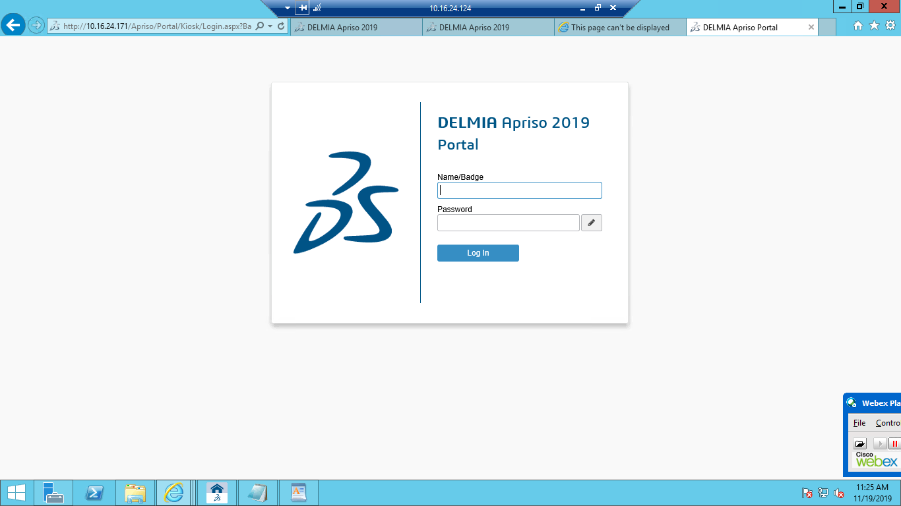

* 1. Navigate to BAT Operations 🡪 UIUX Operations 🡪 Operator Portal

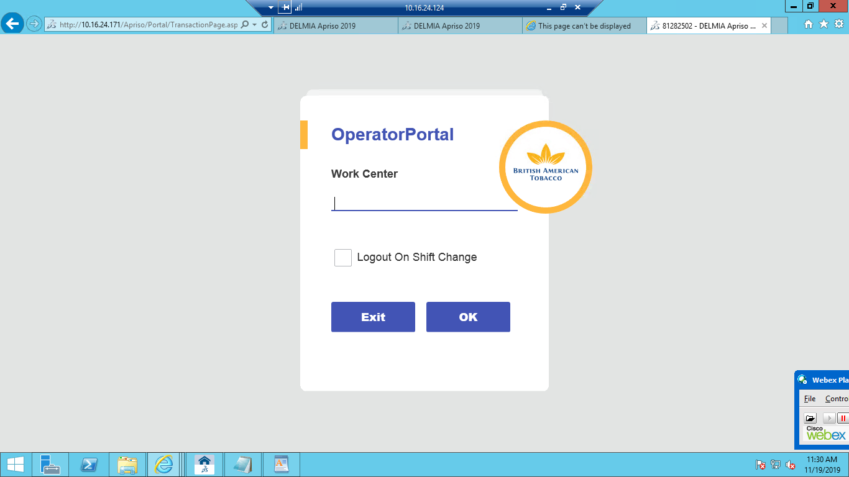

* 1. Navigate to work center 🡪 Click on "Production" tab 🡪 Navigate to "Maker" Operation

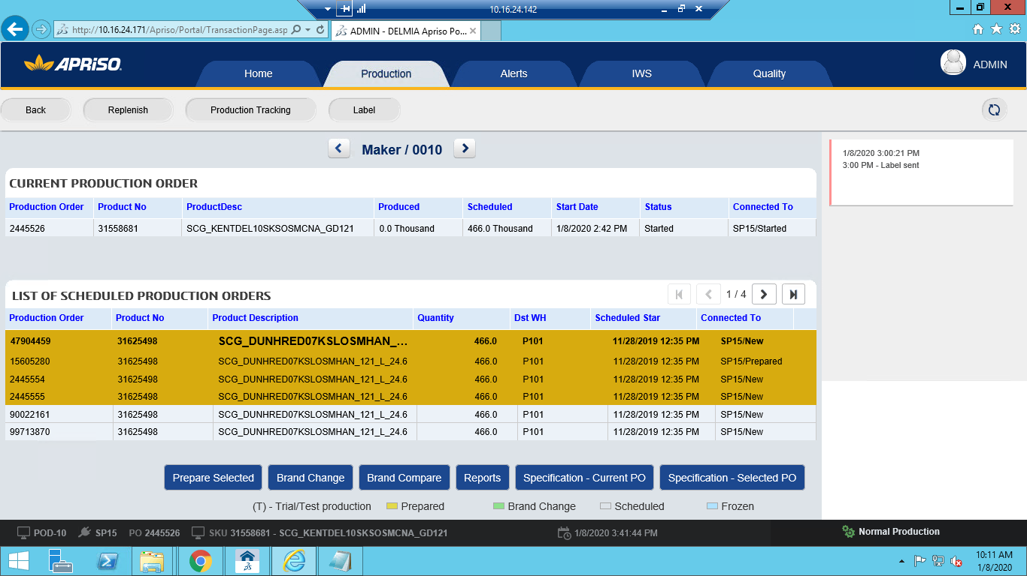

* 1. Product number should be different in current Production order list and scheduled production order list

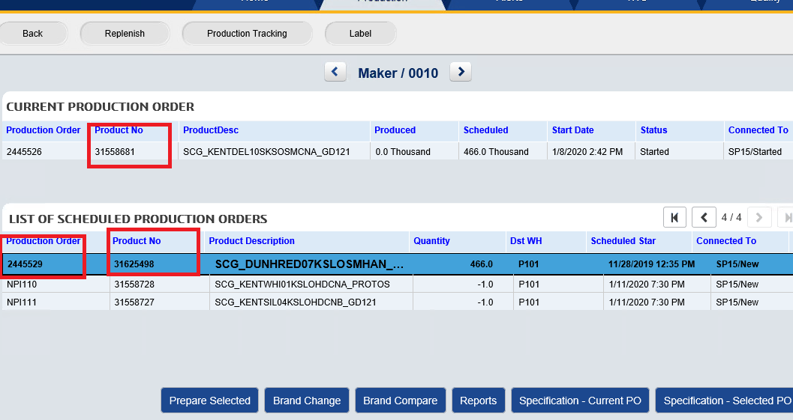

* 1. Select PO and click on "Prepare Selected" button 🡪 Click on "Confirm" button in ACK-10 popup

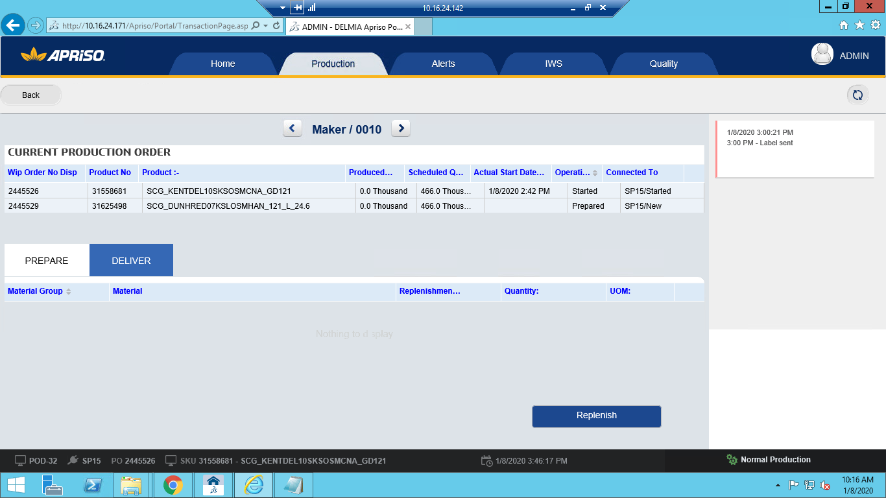

**Component: 2. ADM_JobHistory_MM_Check Change PO Status message**

2.1. Navigate to Immidiate Job History 🡪 search **'ProductionOrderData'** in

synchronization queue 🡪 PO start to prepare – PREPARE

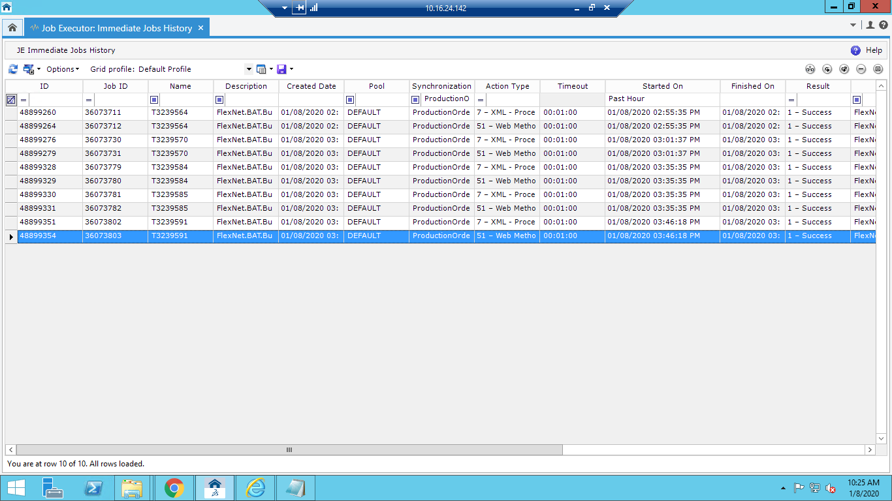

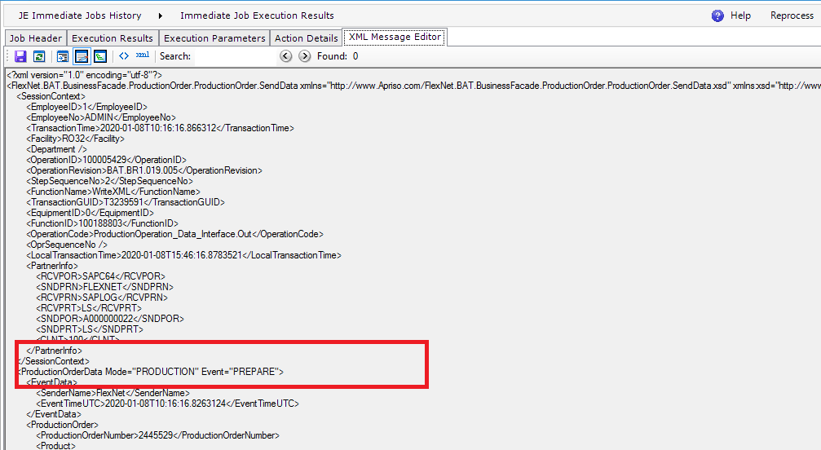

**Component 3. SMD_POD-21_OP_Compare visual standards between POs for maker**

3.1. navigate to BAT Operations -> UIUX Operations - > Operator Portal(UXOPP) -> Enter workcenter No and click on OK🡪 Click on "Production" tab🡪

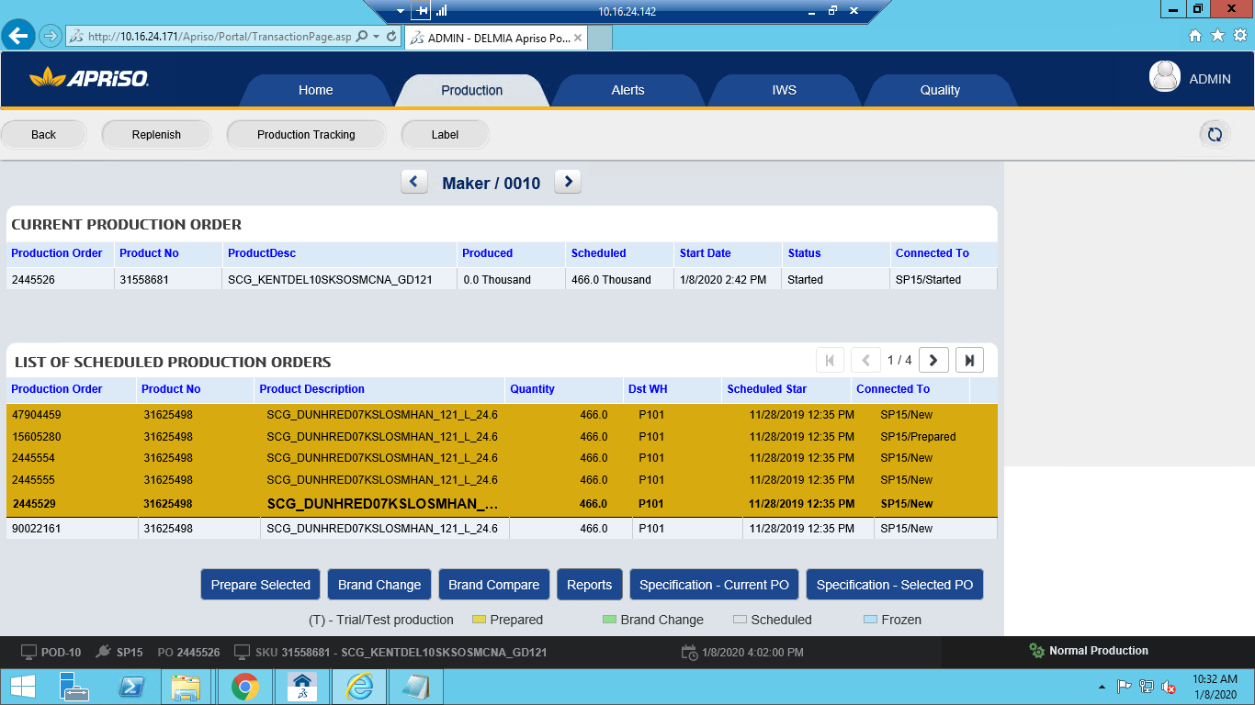

3.2. Click on "Specification - Current PO" button🡪

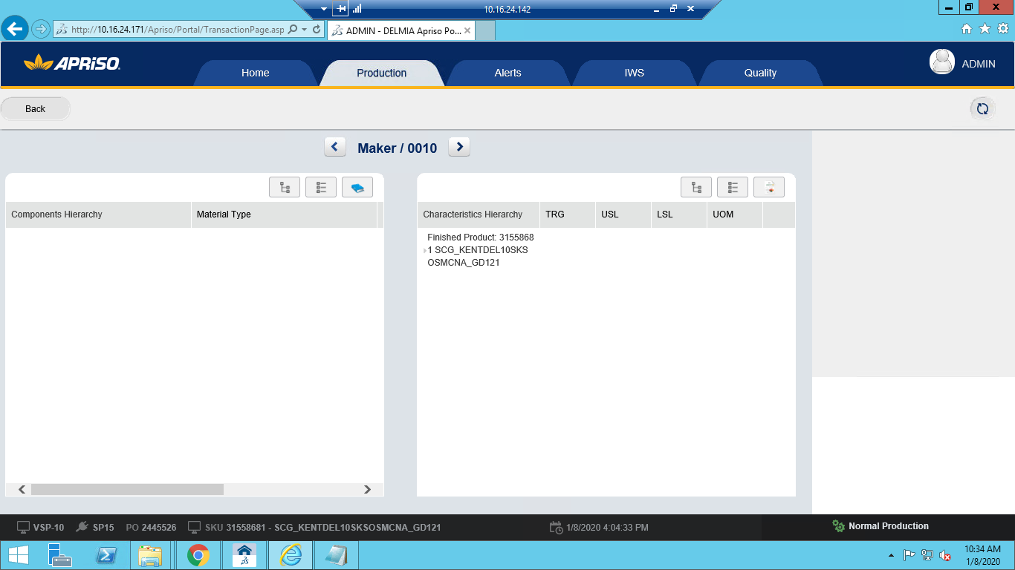

Click on "DMS File hyperlink" in the DMS file

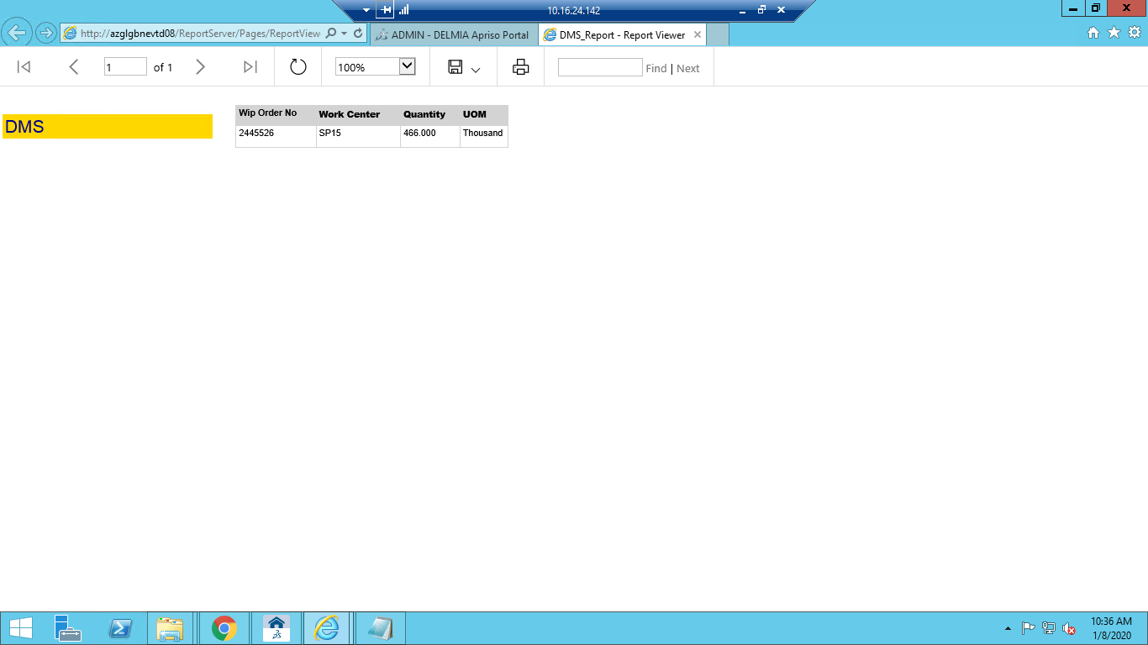

On Operator Portal VSP-10 Click on "back" button

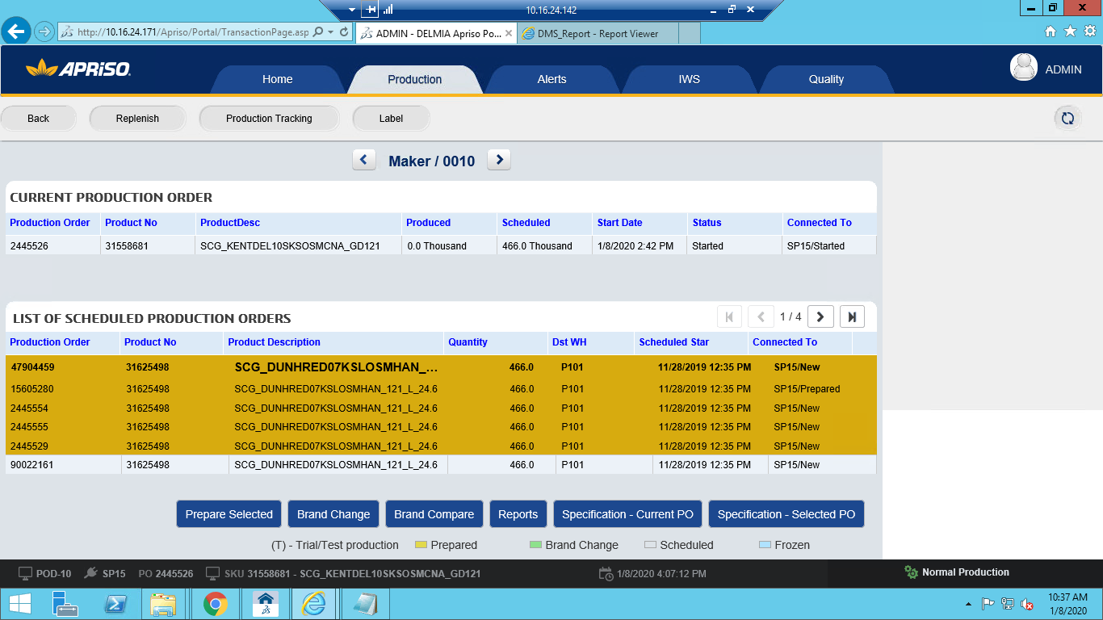

Select a PO which you want to compare Click on "Specification - Selected PO" button 🡪

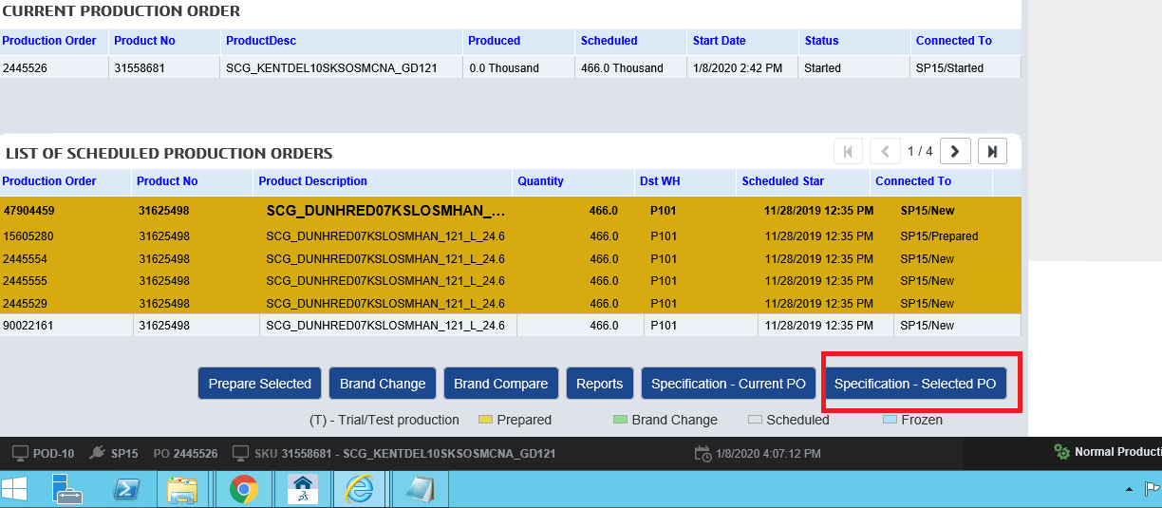

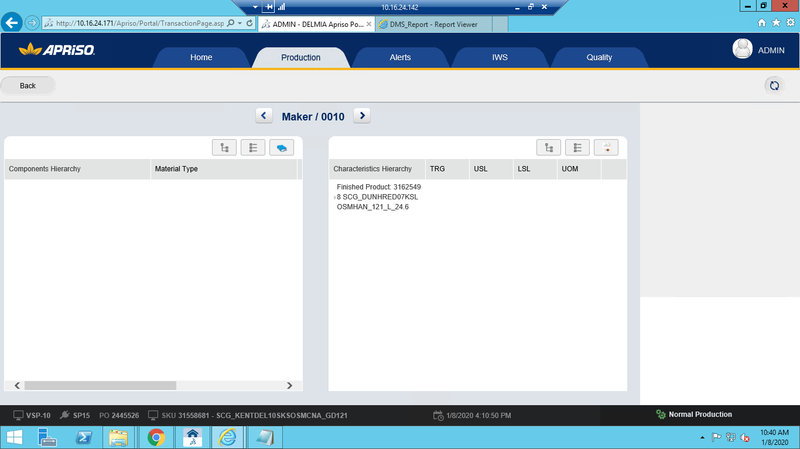

Click on "DMS File hyperlink" in the DMS file row 🡪

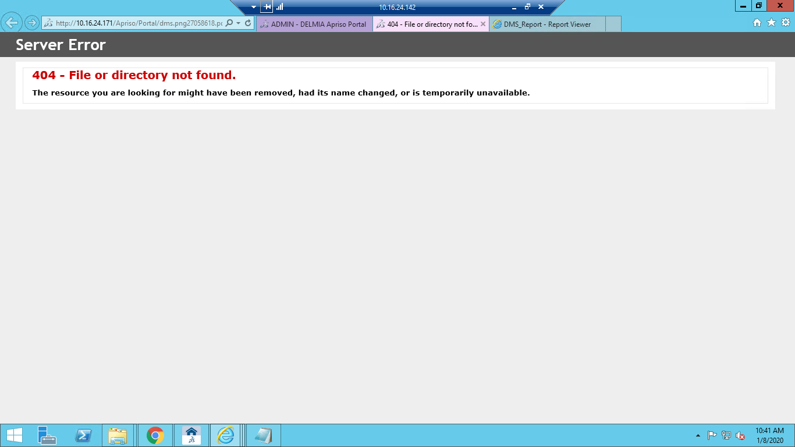

**Component 4. 1302_11– STEP 1 - Start PO with Brand Change Direct printing**

4.1 navigate to BAT Operations -> UIUX Operations - > Operator Portal(UXOPP) -> Enter workcenter No and click on OK 🡪 Click on "Production" tab 🡪 Navigate to "Maker" Operation

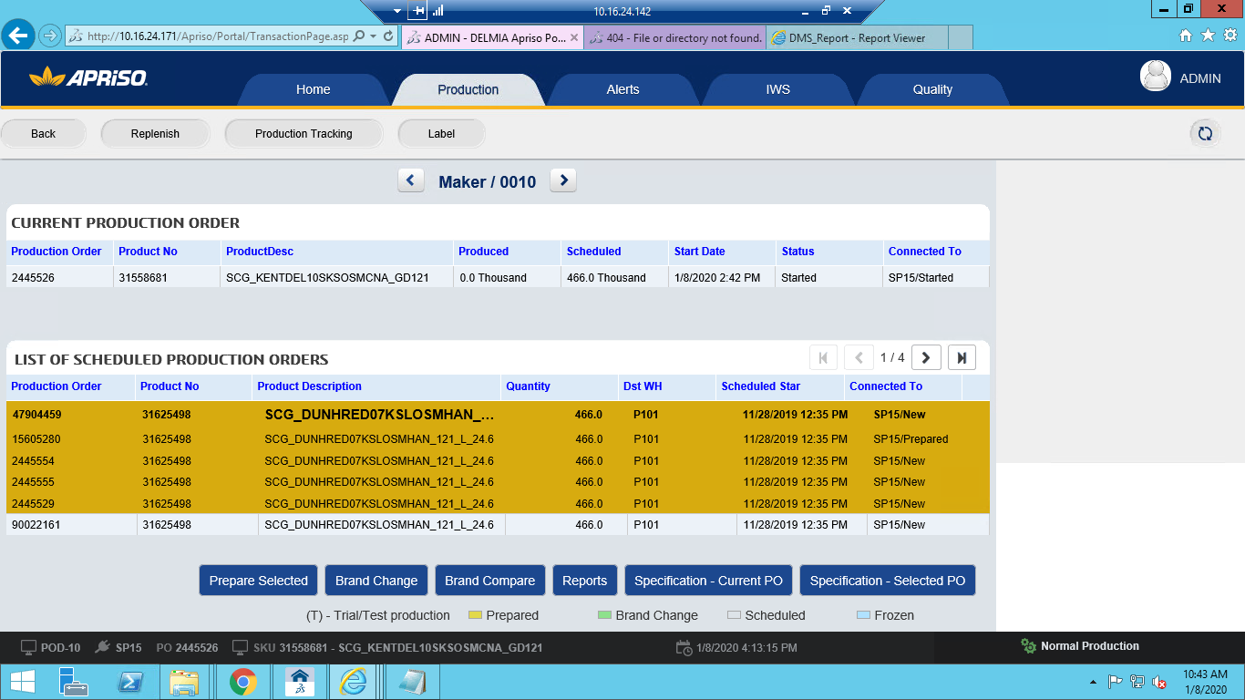

Click on "Brand Change" button🡪

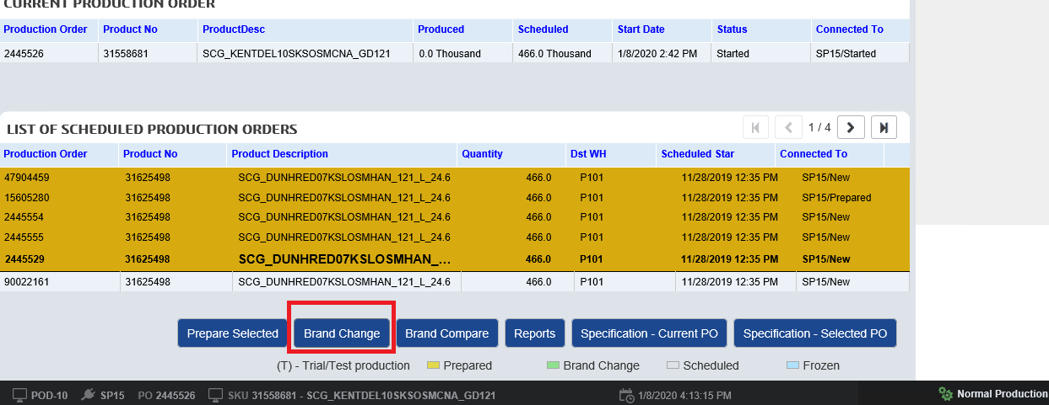

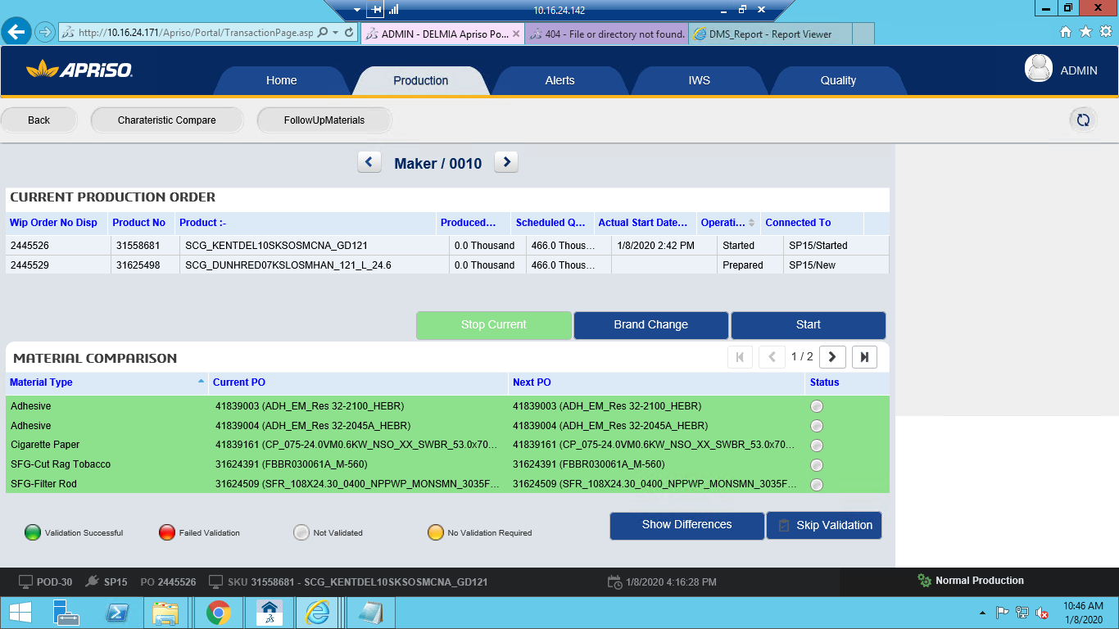

Click on "Stop Current" button 🡪

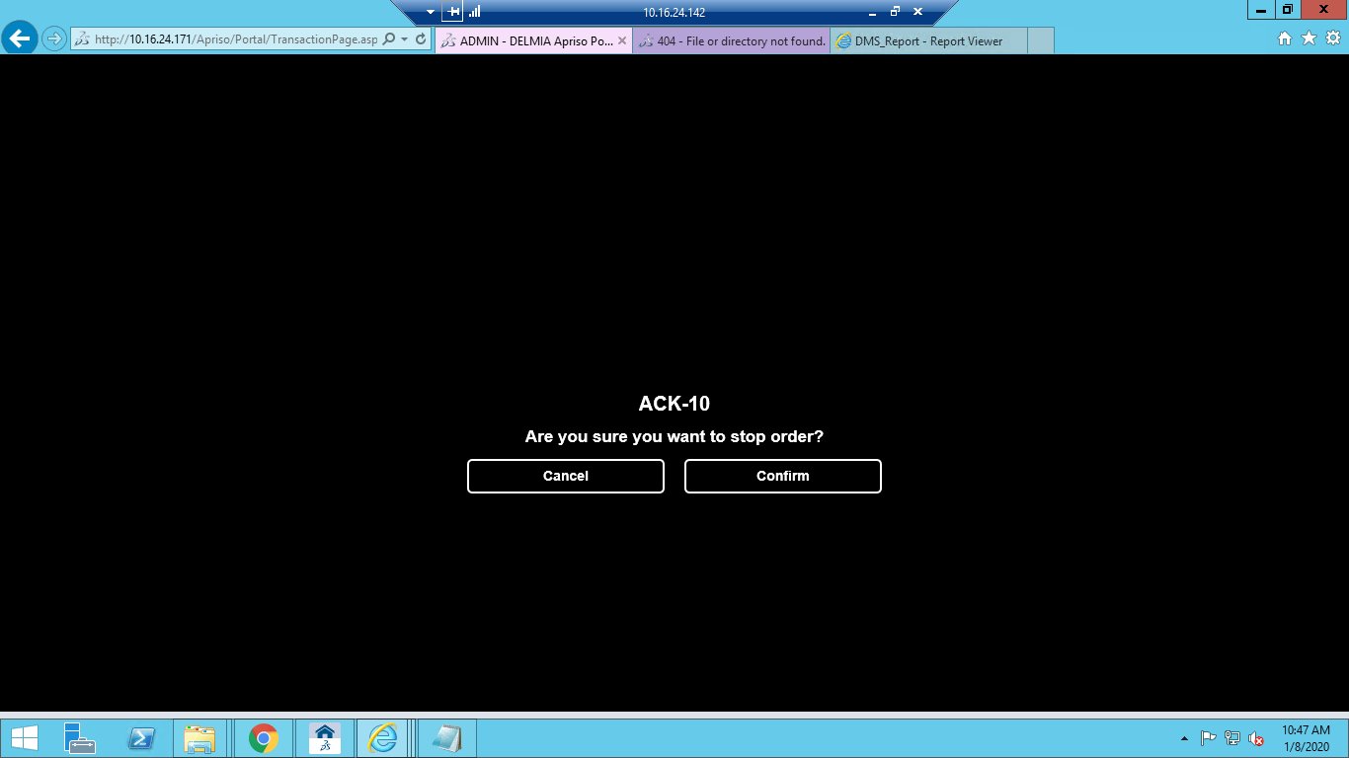

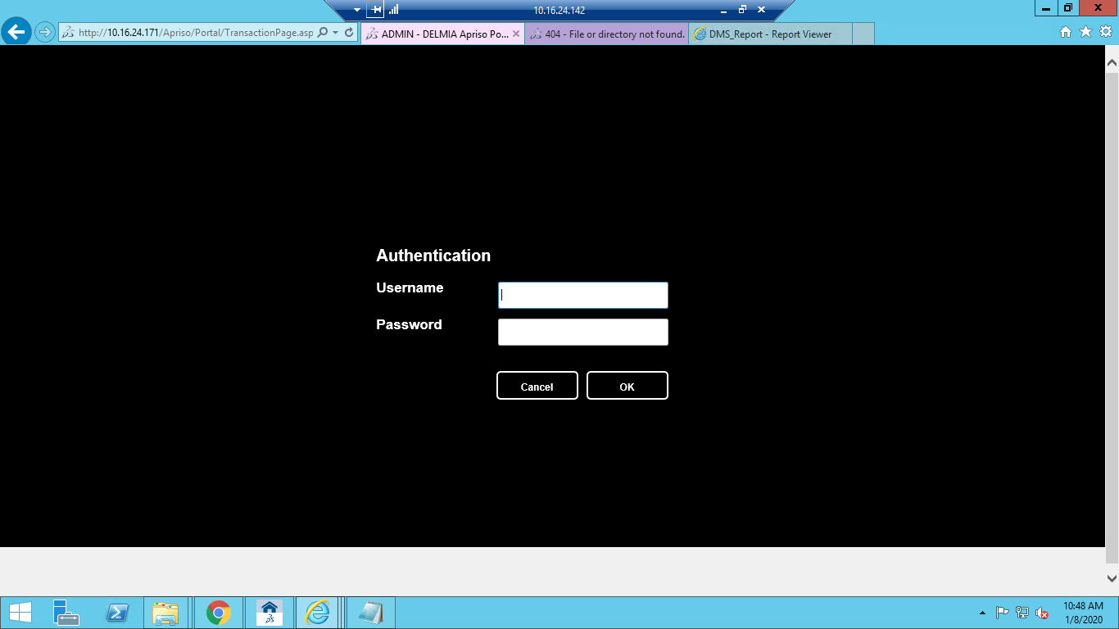

Enter “**Authentication“**  username and password

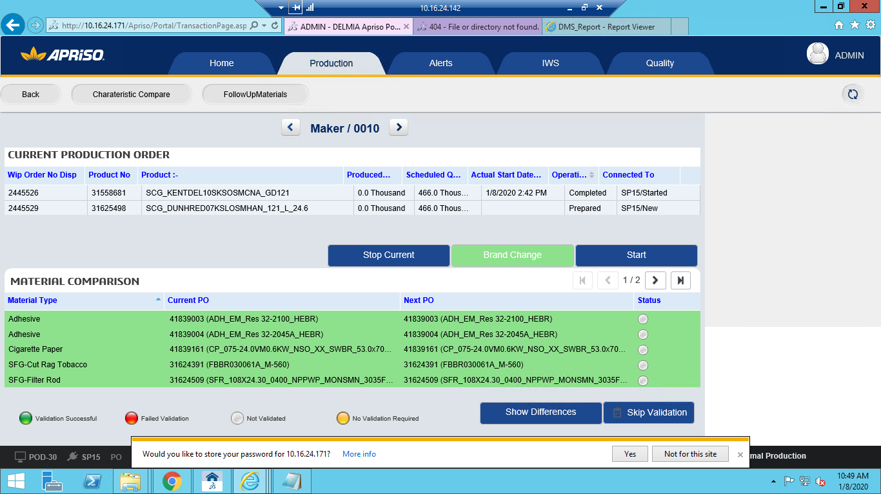

**PERFORM BRAND CHANGE**

**Component 5. MFG_POD-30_OP_Brand Change Initiate**

5.1. Navigate to OPP using browser as follows BAT Operations -> Operator Portal (UIUXOPP) 🡪

Click on 'Production' 🡪 Select a prepared PO with different SKU. And click on 'Brand Change'

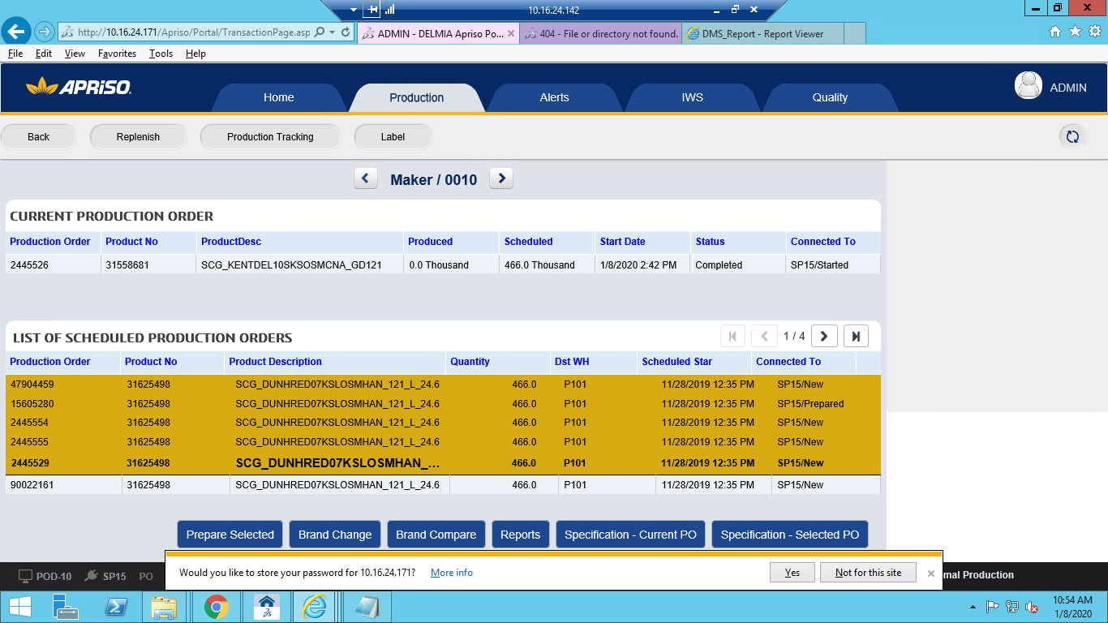

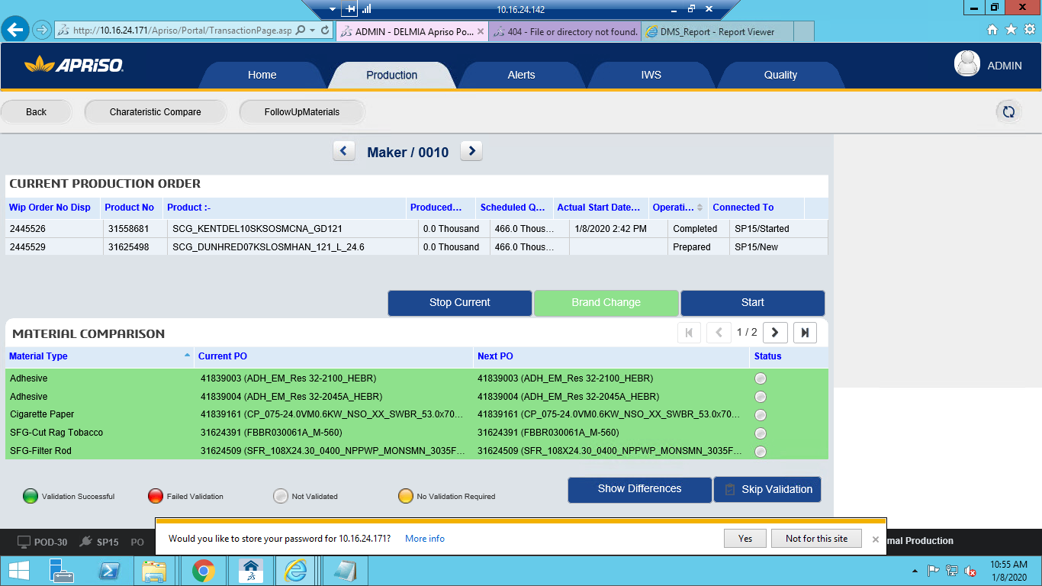

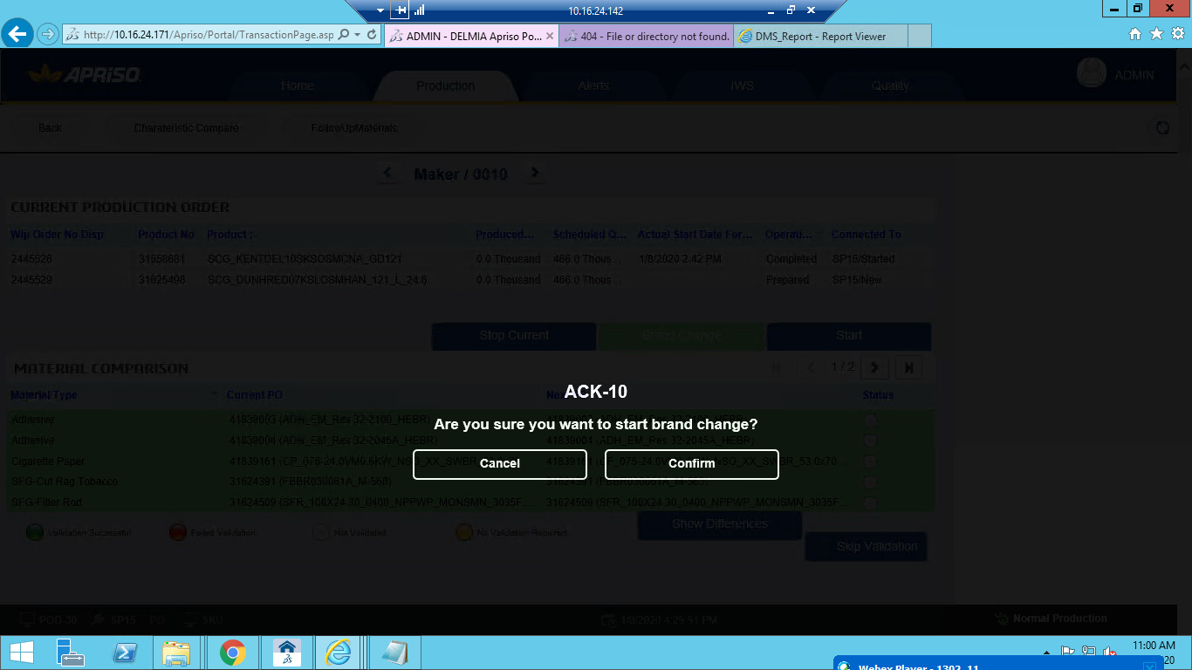

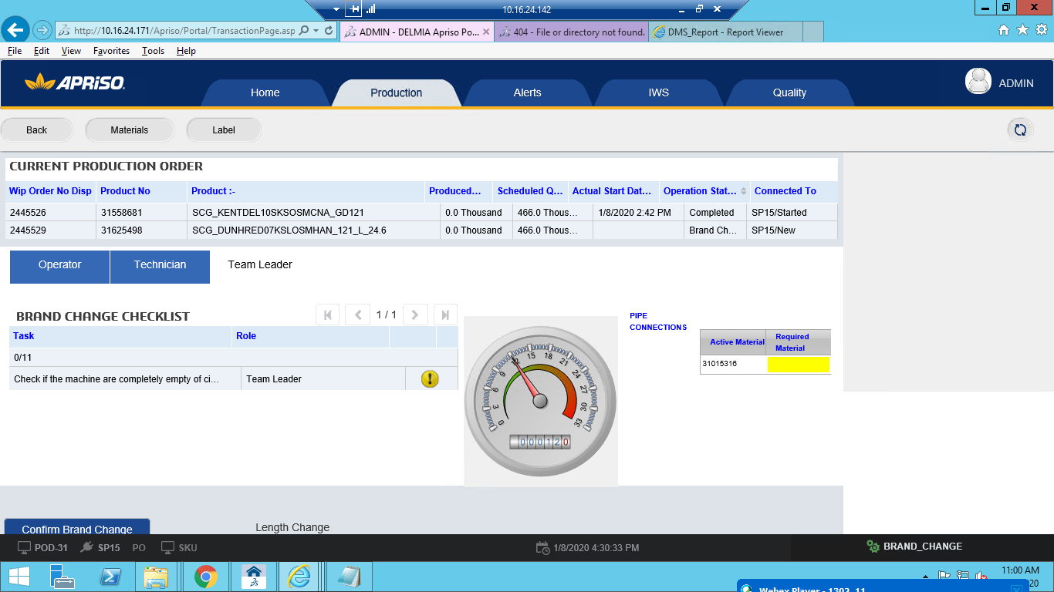

Observe the "Operator" checklist 🡪 Select all Operator checklist

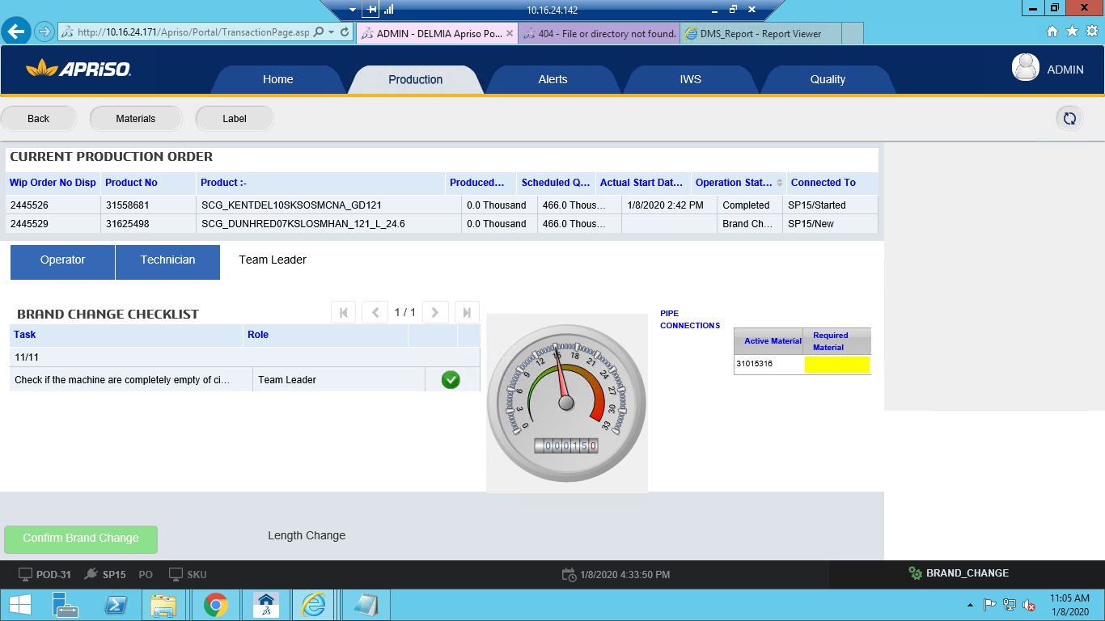

Select a wrapping type if its FMD and click on 'Confirm Brand Change' 🡪

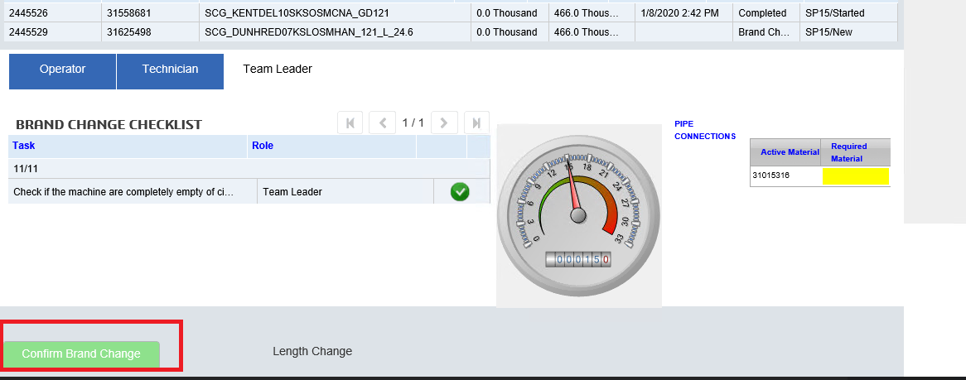

Enter username and password. And click on 'OK'

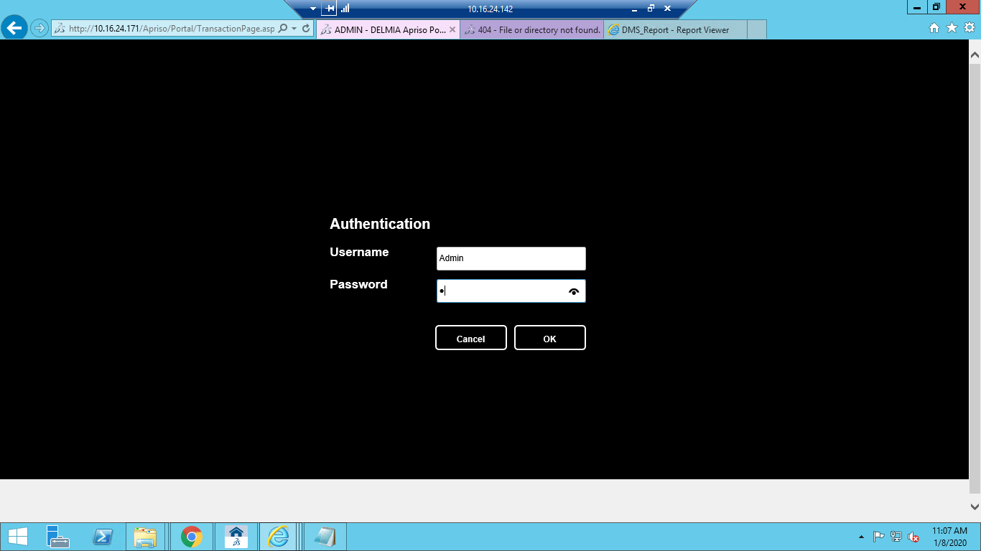

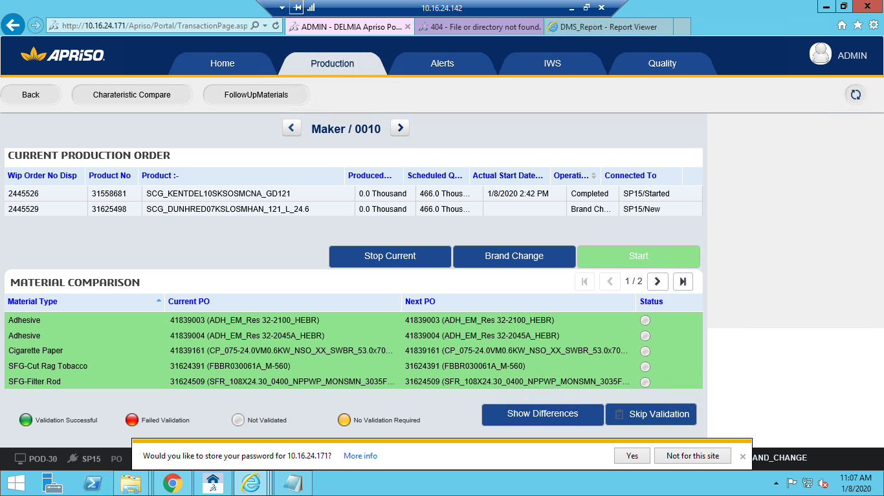

Select a material from 'Material Comparison' grid and click on 'Skip Validation' Button 🡪

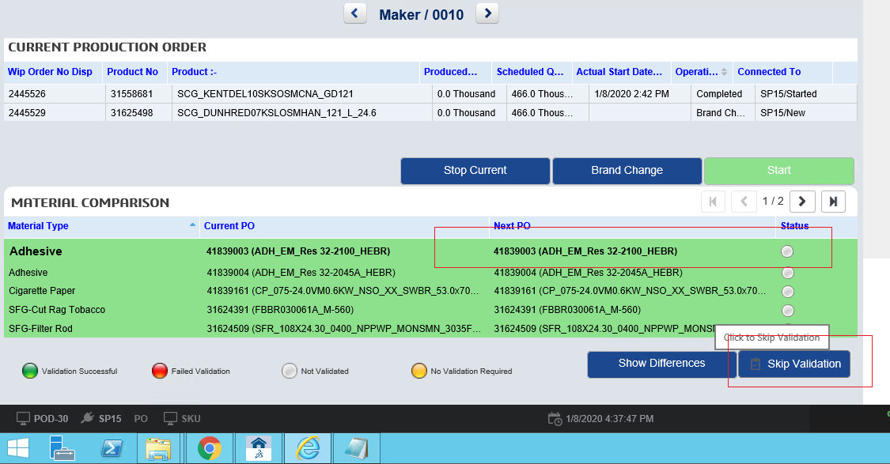

Enter username and password. And click on 'OK' 🡪 Write a comment and click on 'Save' 🡪

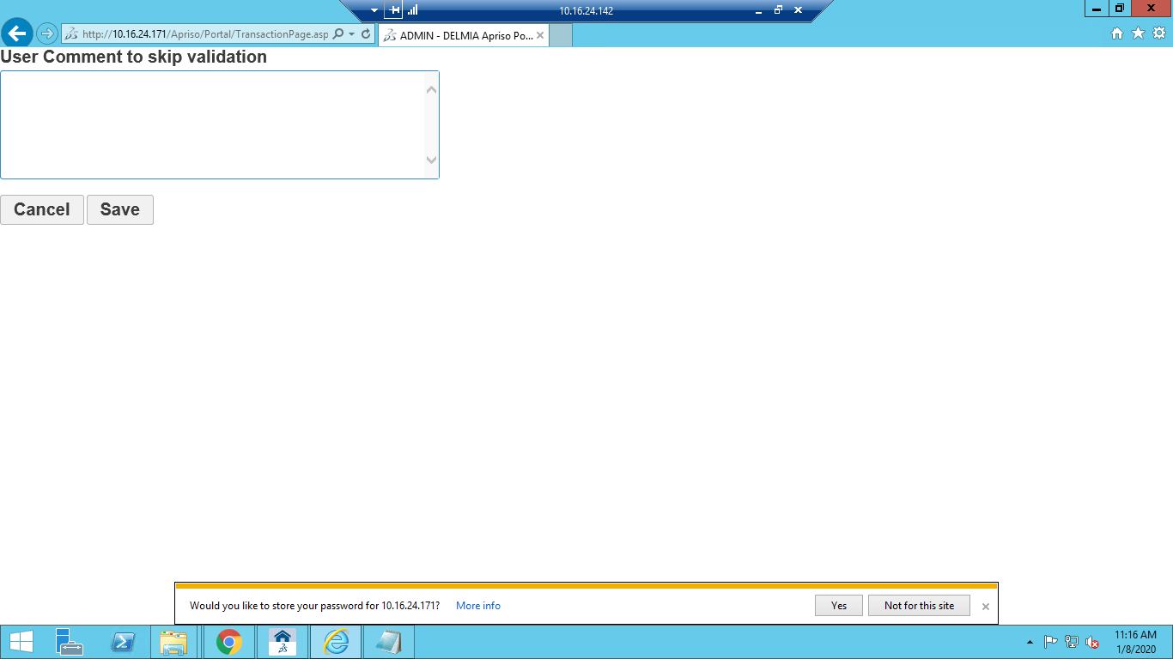

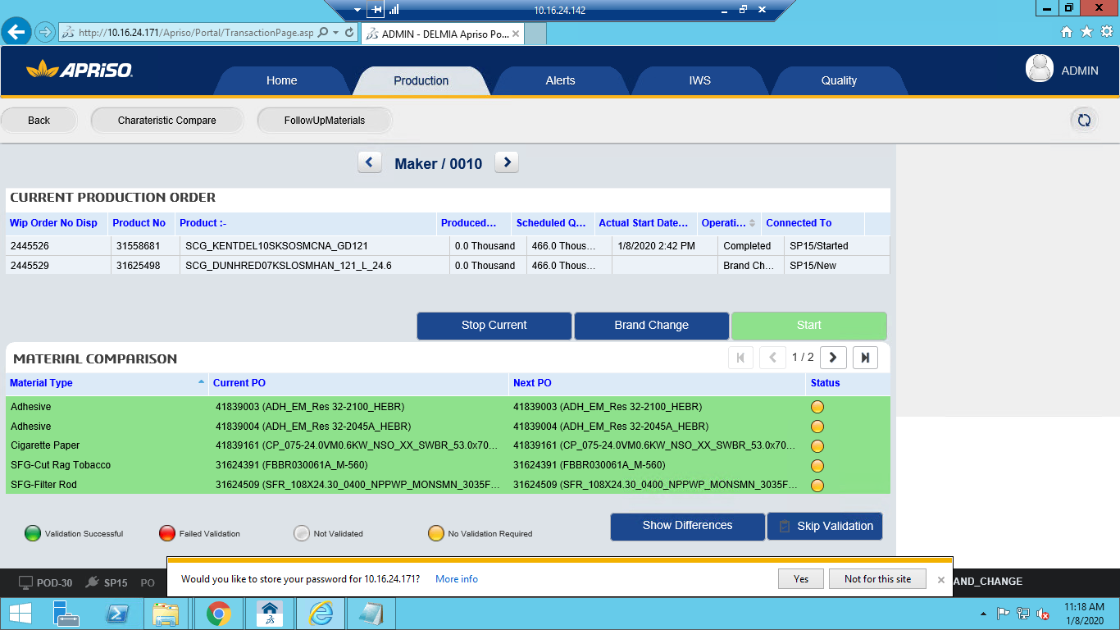

Navigate to SMD work center 🡪 Click on "Production" tab🡪 Select PO(having different SKU than

current PO) and/or is in Brand Change Status from Scheduled Orders list and Click on "Brand Change"

button.

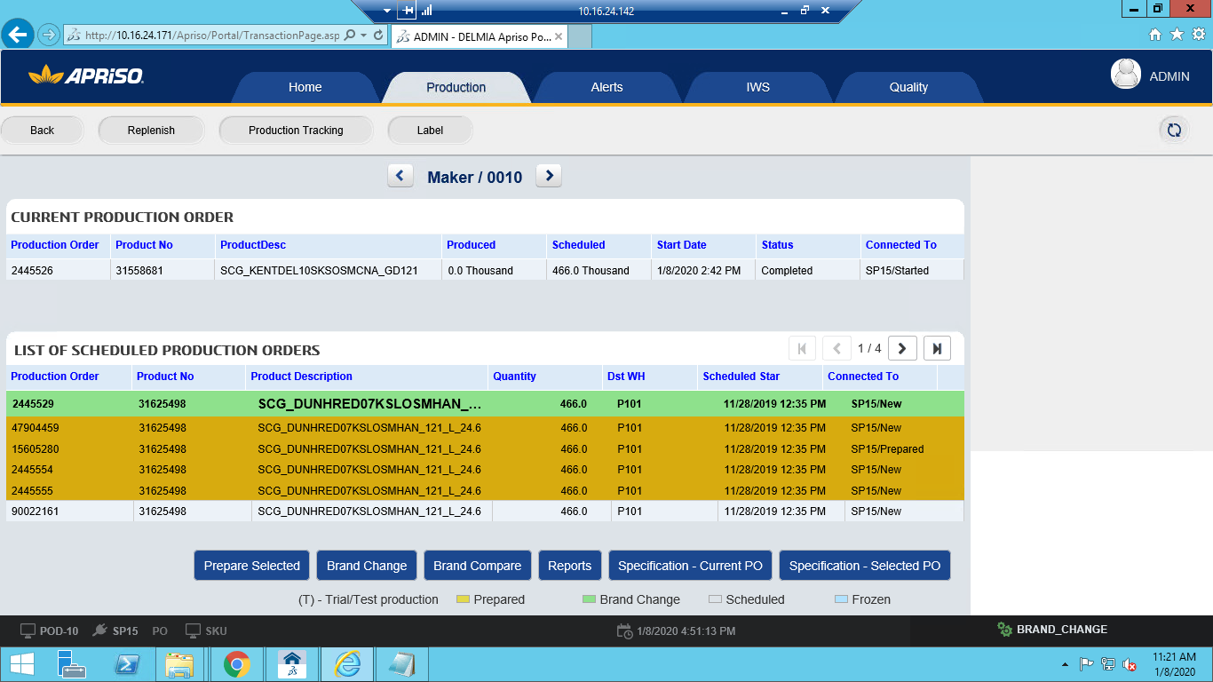

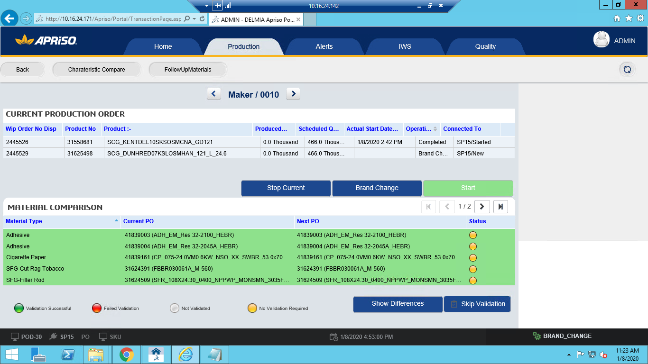

Click on "Characteristic Compare" button 🡪

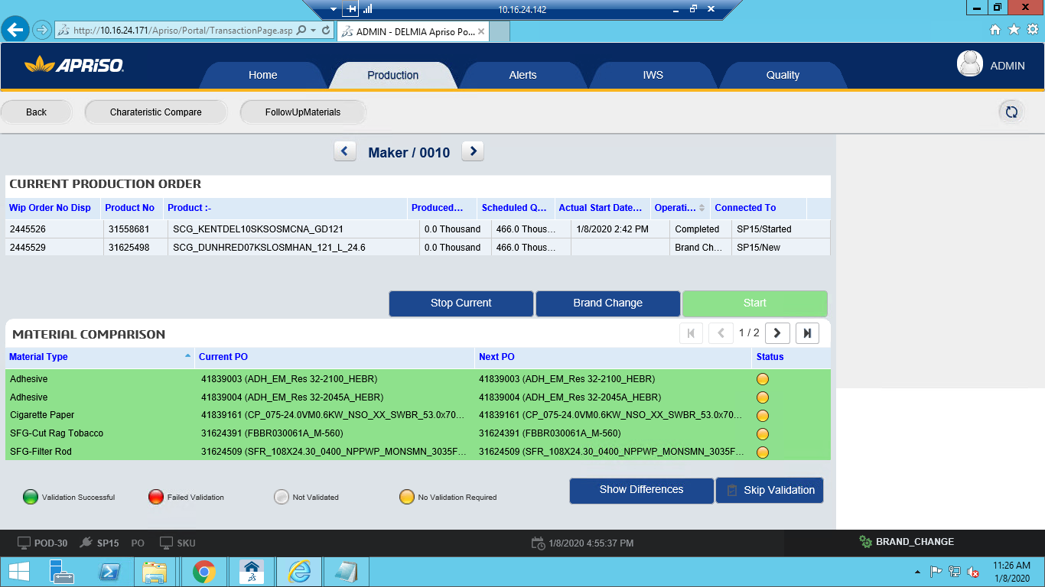

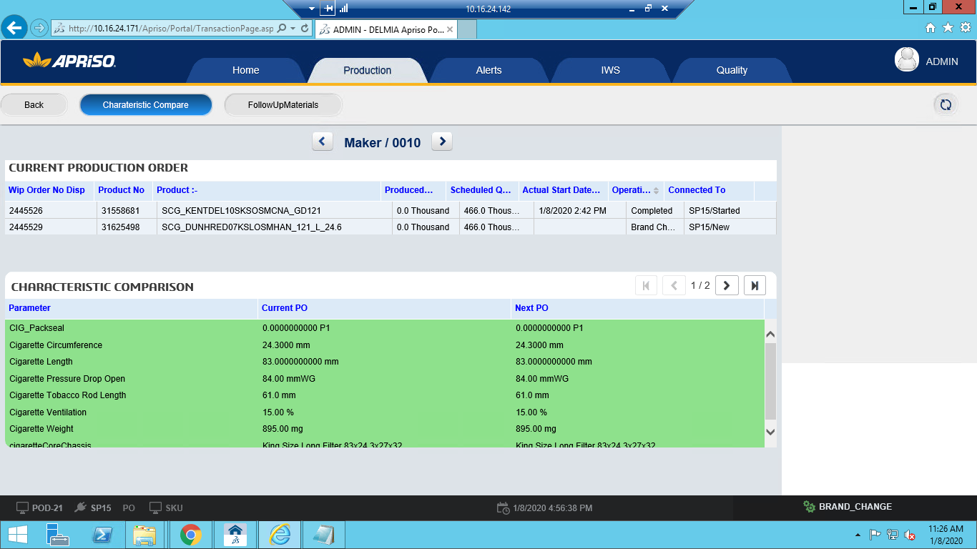

Observe the Parameters colors 🡪

**Component 6 . 1302_11– STEP 2 - Start PO with Brand Change Direct printing**

6.1. navigate to BAT Operations ->Operator Portal(UXOPP) -> Enter workcenter No and click on OK 🡪 Click on "Production" tab🡪 Navigate to "Maker" Operation 🡪 Click on "Specification - Current PO" button 🡪

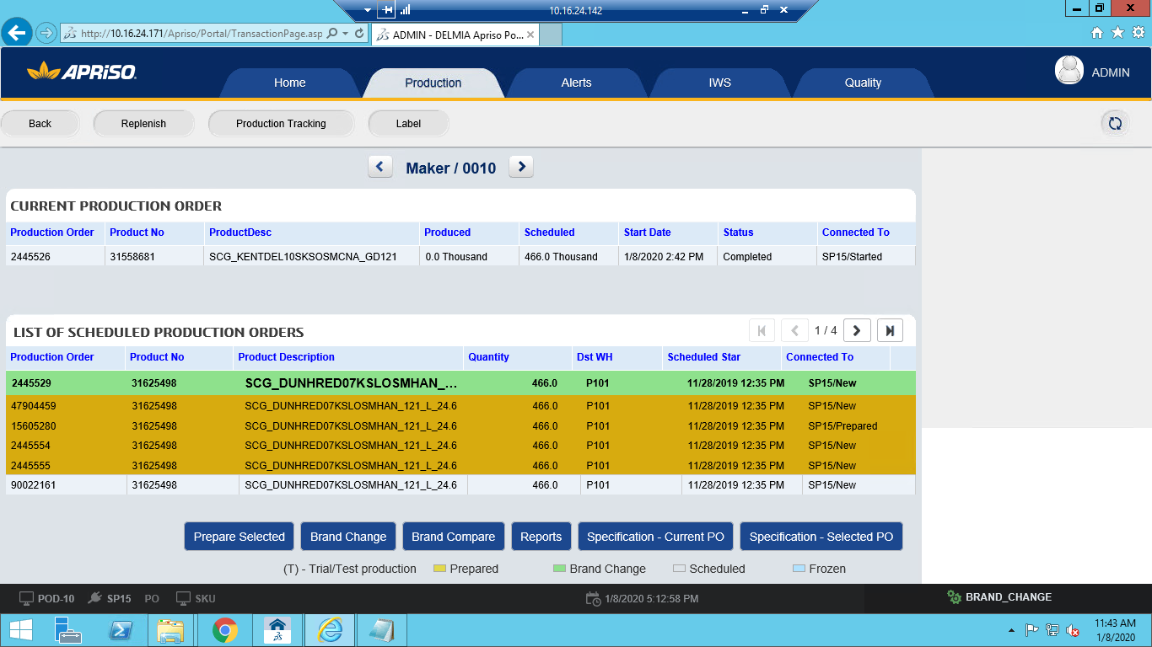

Click on "Specification - Current PO" button🡪Click on Expand button of the Component Hierarchy Grid 🡪

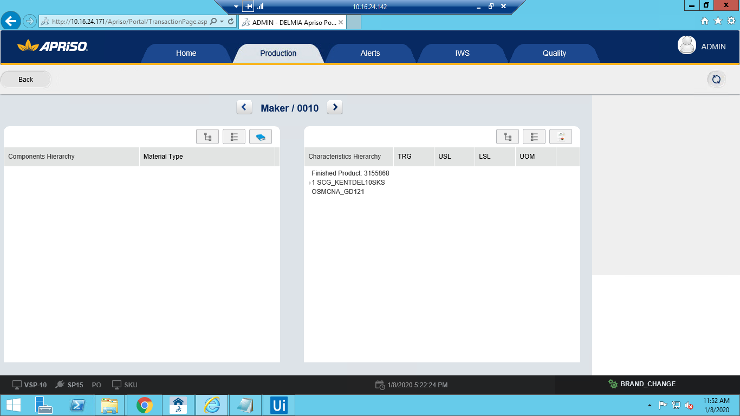

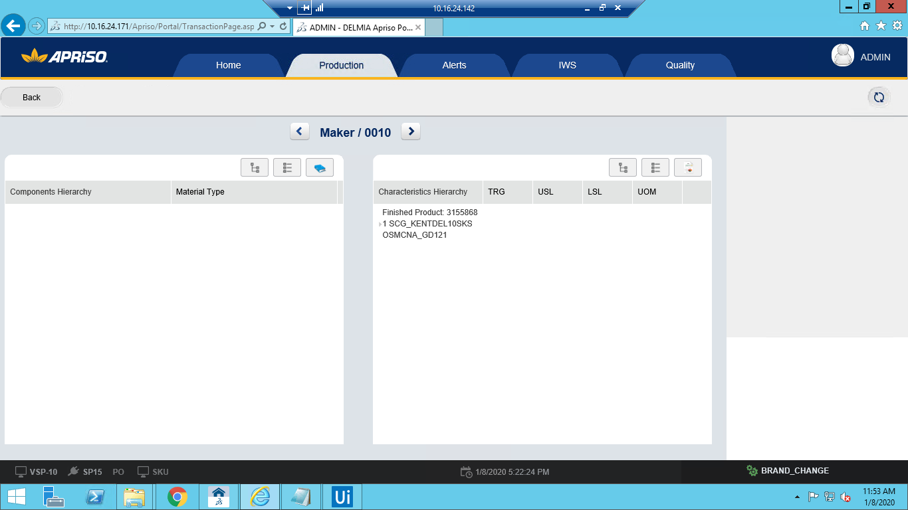

Click on Expand button of the Characterstics Hierarchy Grid🡪 Click on Back Button

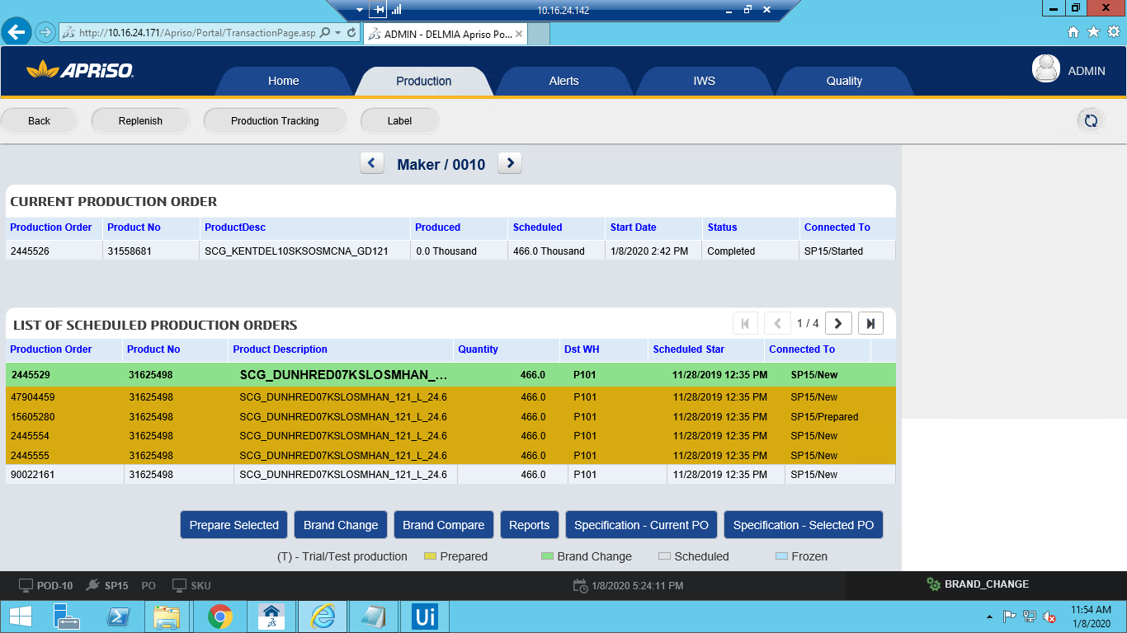

Click on "Specification - Selected PO" button 🡪

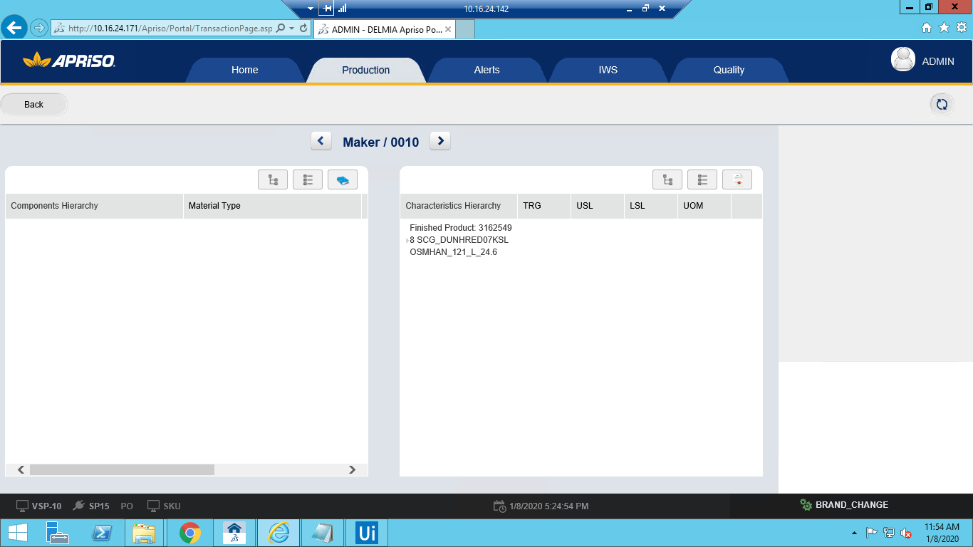

**Component 7 . SMD_POD-30_OP_Start Production Order for maker**

7.1. navigate to BAT Operations -> UIUX Operations - > Operator Portal(UXOPP) -> Enter workcenter No and click on OK 🡪 Click on "Production" tab 🡪 Navigate to "Maker" Operation 🡪

Select a prepared PO (if same SKU) or a PO in brand change (if different SKU) and click on "Brand Change" button

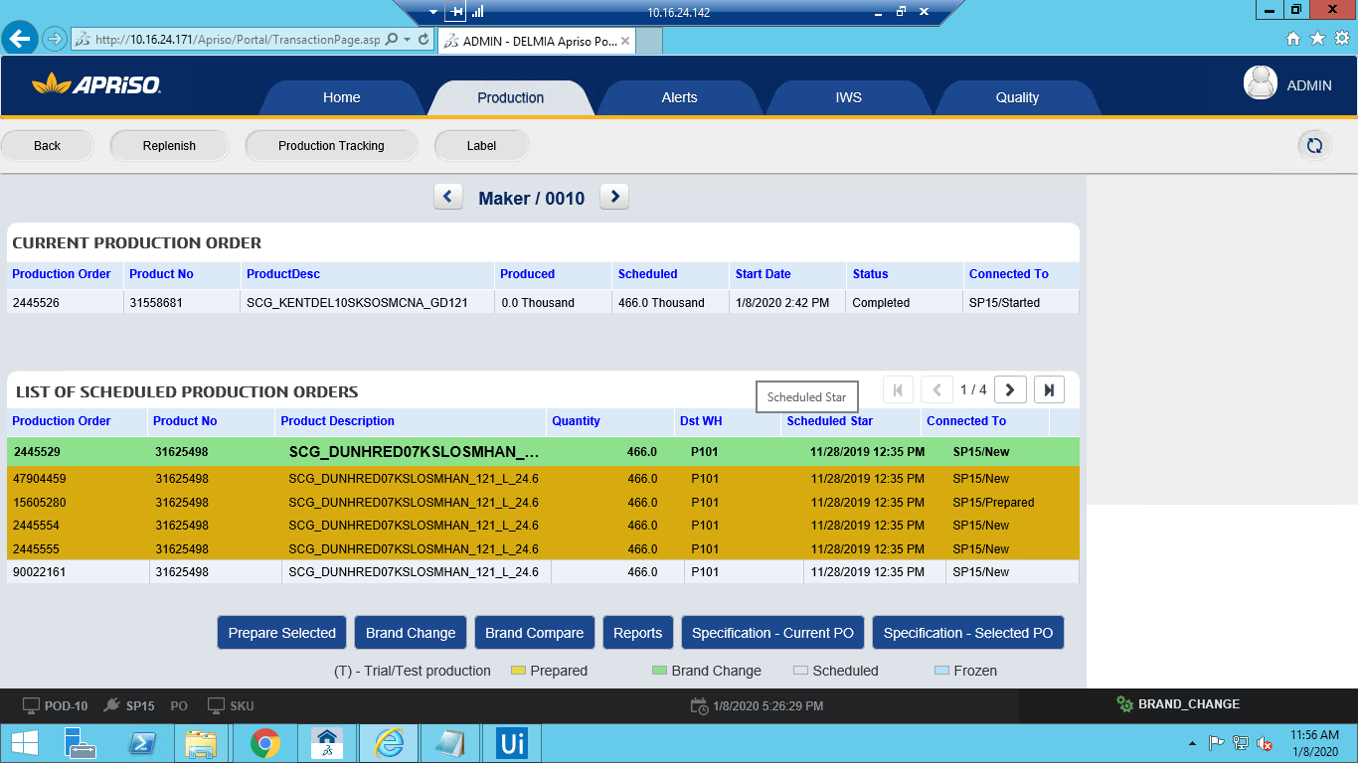

Select a prepared PO (if same SKU) or a PO in brand change (if different SKU) and click on "Brand Change" button 🡪

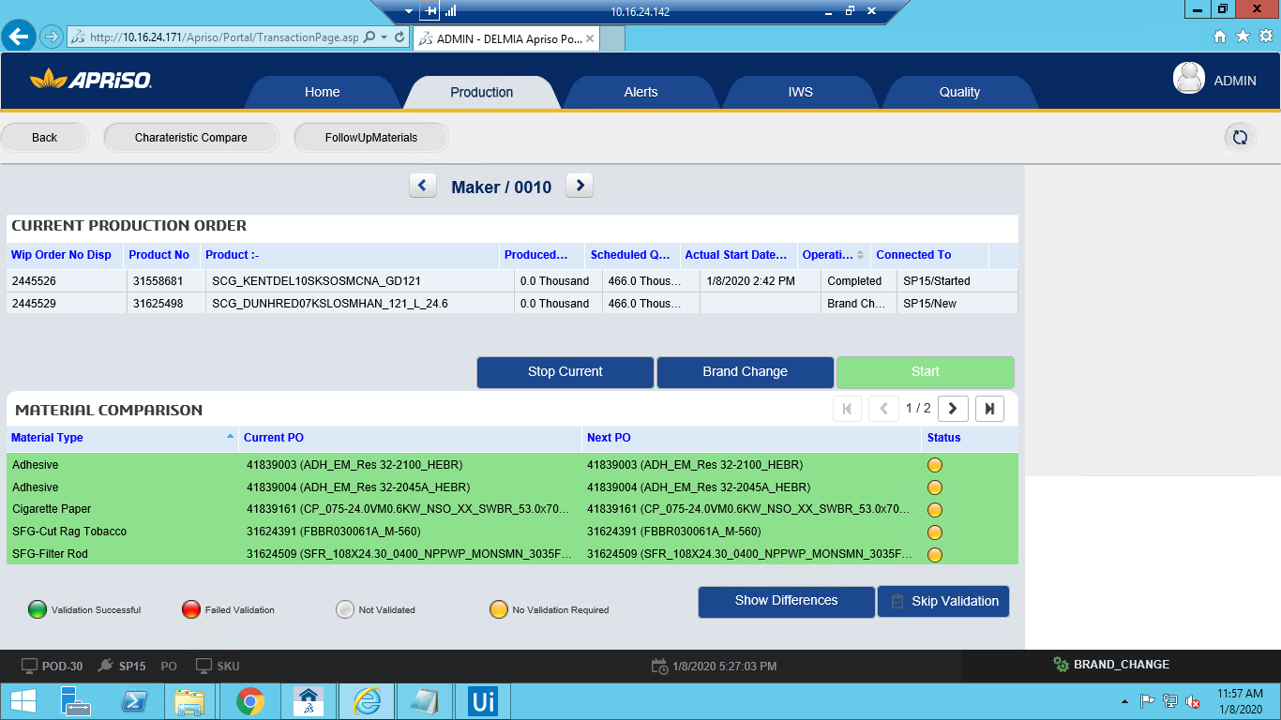

Click on "Start" Button 🡪

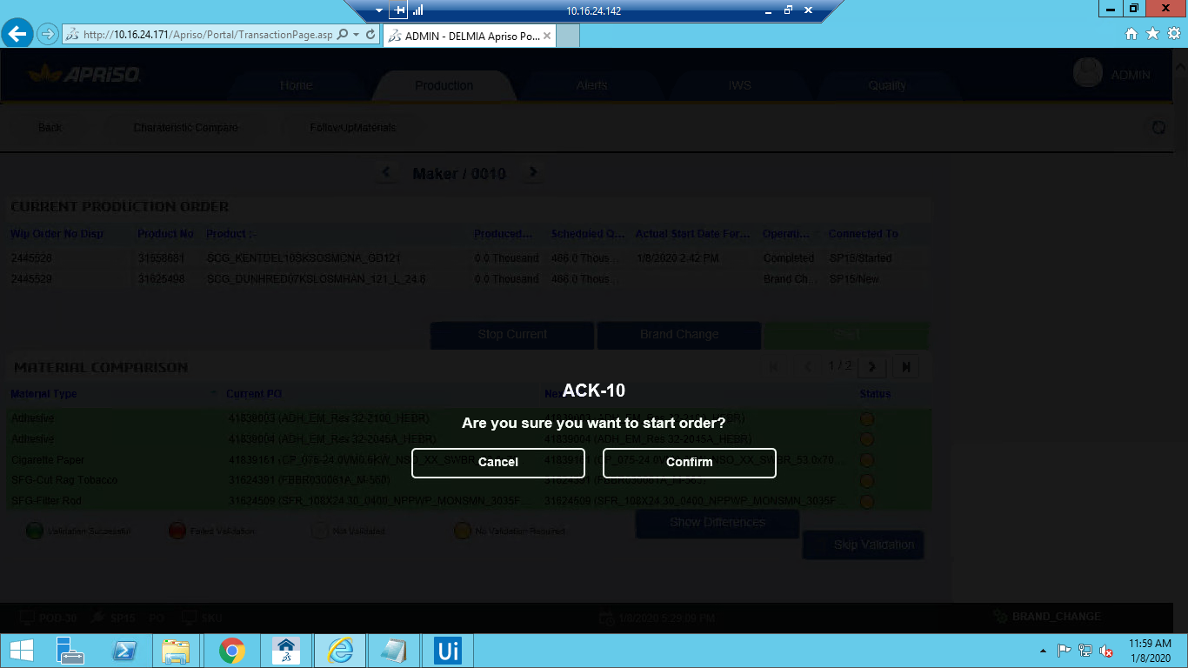

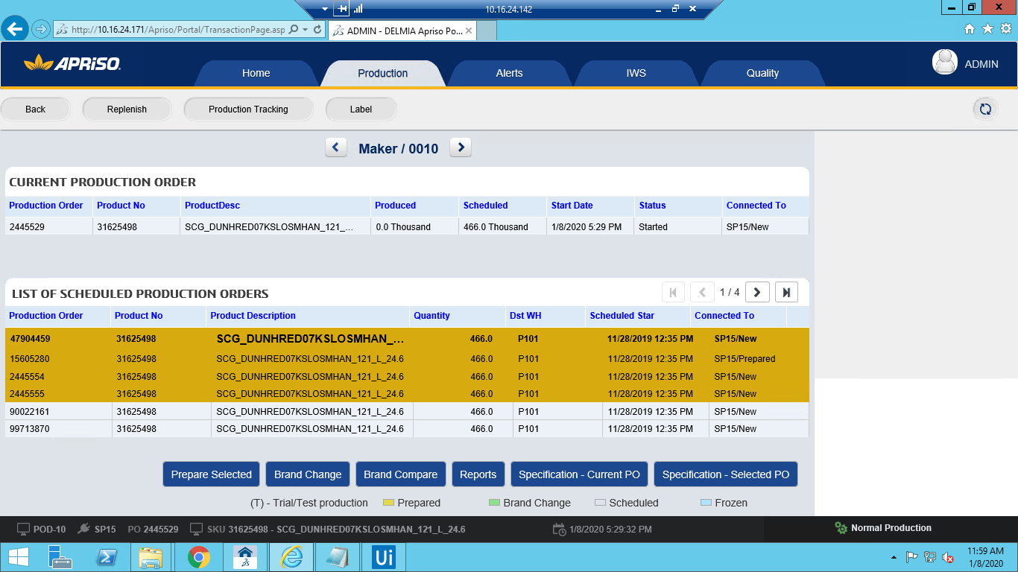

Validate all the materials shown in the material comparision screen by "Component Validation (CPV)" operation or Skip validation 🡪

**Component 8 . SMD_POD-10_OP_Prepare PO for packer**

81. 🡪Navigate to work center 🡪 Click on "Production" tab🡪 Select PO and click on "Prepare Selected" button

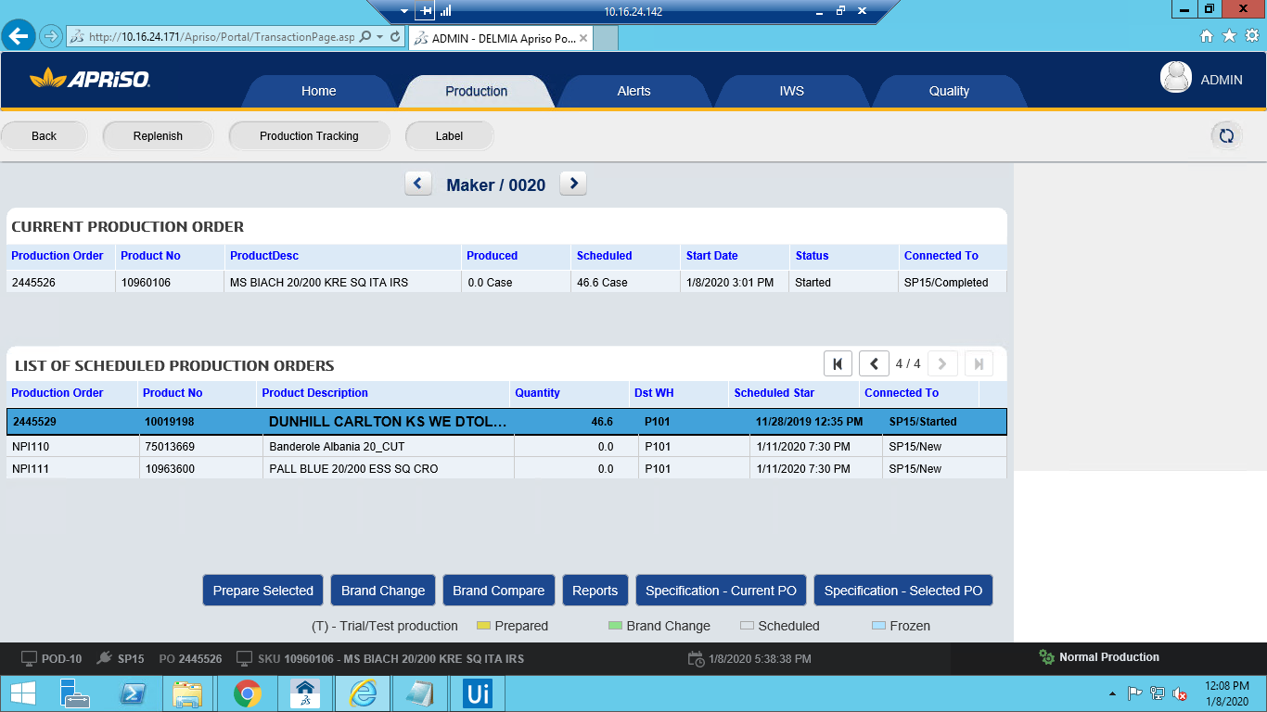

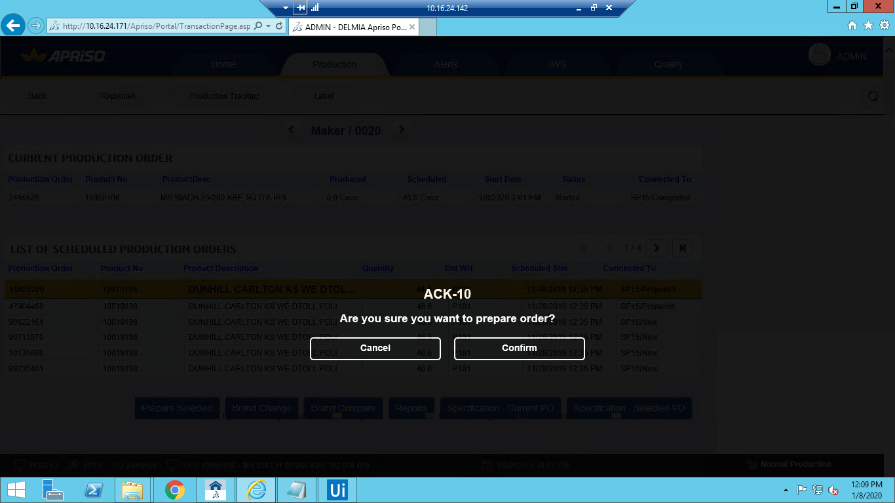

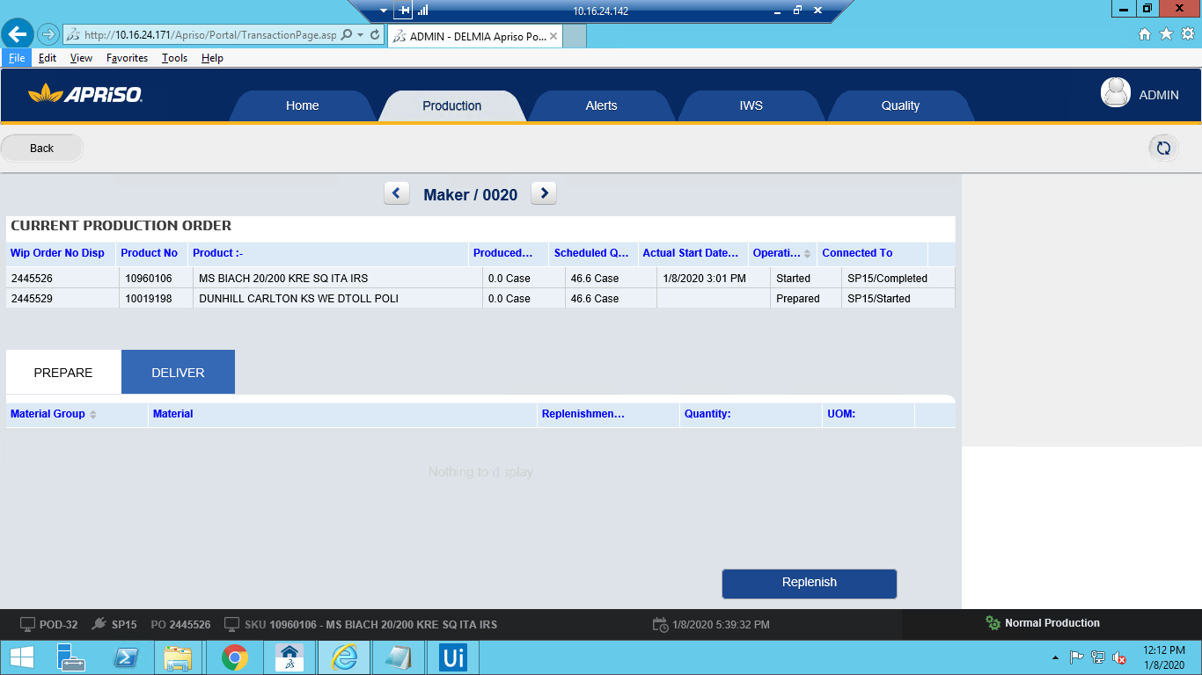

**Component 9 . MFG_POD-32_OP_Select materials for preparation before brand change**

9.1 . Login into work center 🡪 Click on "Production" tab🡪 Select PO and click on "Prepare Selected" button 🡪 Click on "Confirm" button in ACK-10 popup 🡪 Enter the Quantity and click on Replenish button 🡪 Put "TransferRequirement" in synchronization queue and serach for the message 🡪 Check the details

**Component 10 . SMD_POD-21_OP_Compare visual standards between POs for packer**

10.1. navigate to BAT Operations -> UIUX Operations - > Operator Portal(UXOPP) -> Enter workcenter No and click on OK 🡪Click on "Production" tab 🡪 Click on "Specification - Current PO" button

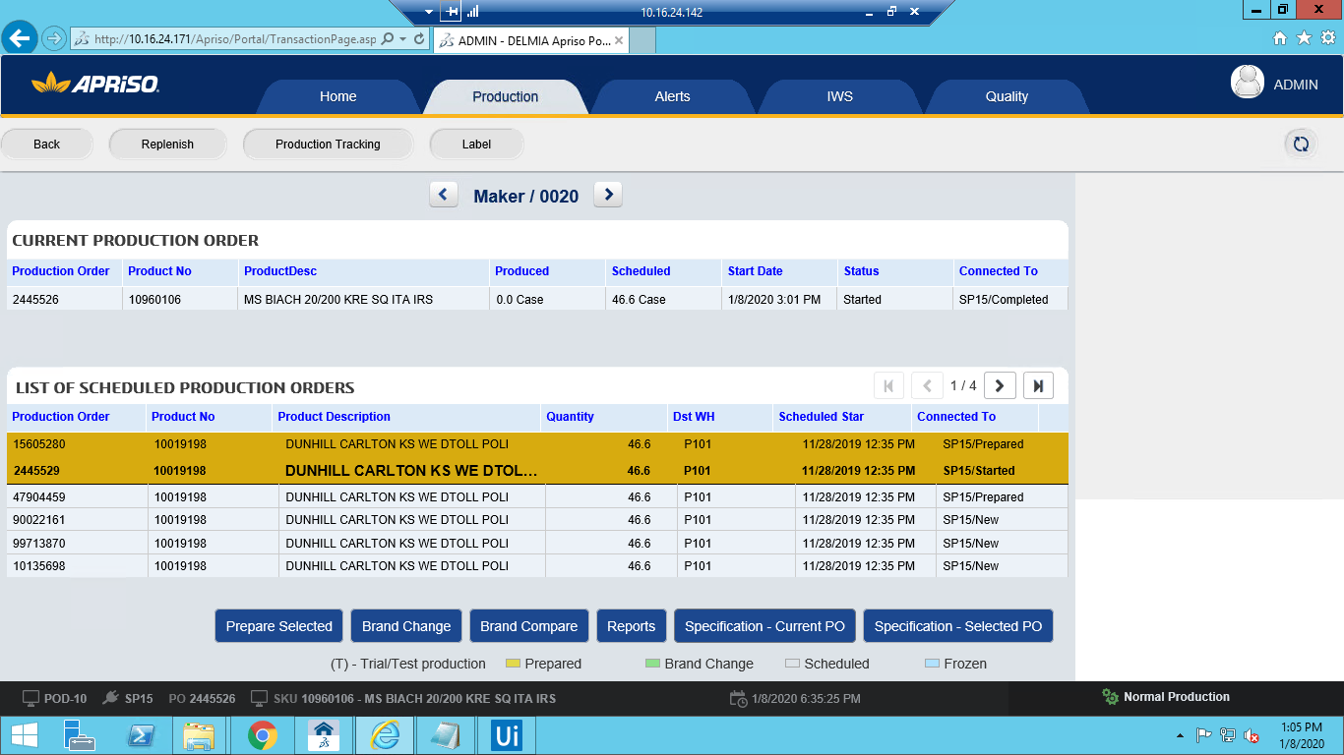

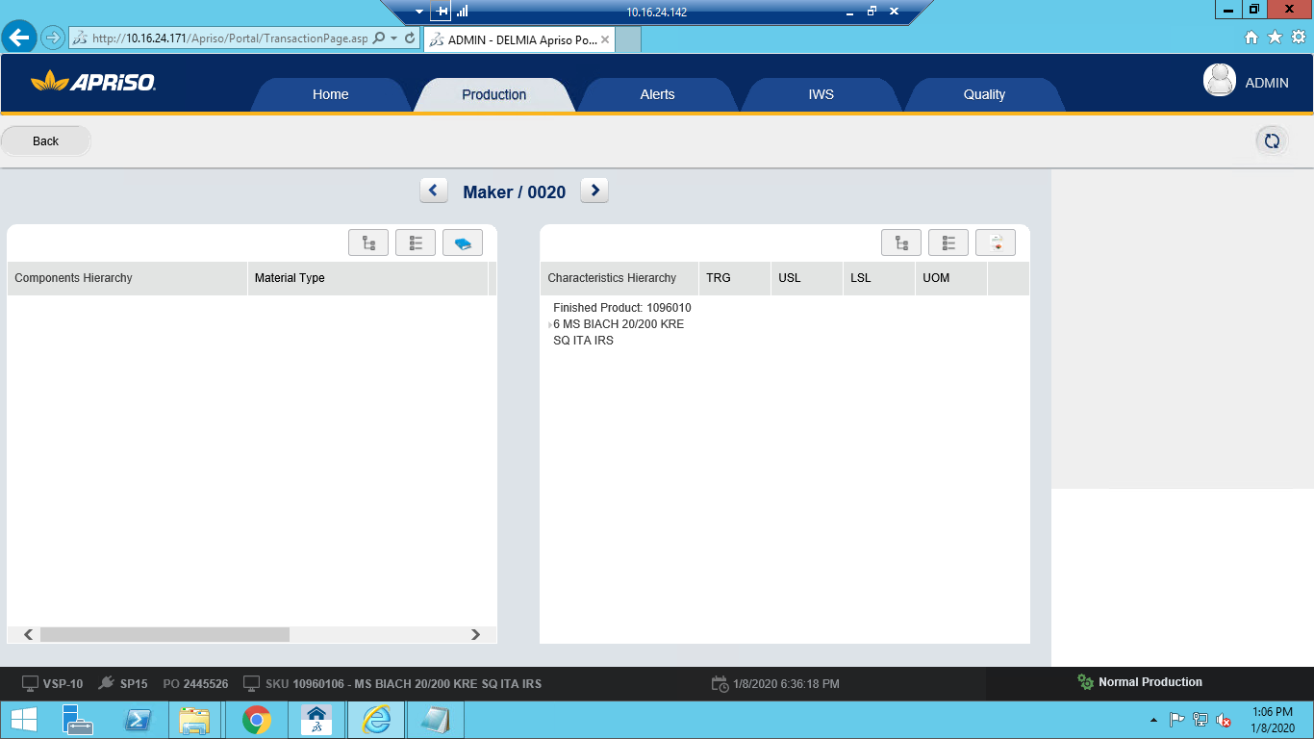

**Component 11. SMD_POD-30_OP_Stop Production Order for packer**

Step 11.1. navigate to BAT Operations -> UIUX Operations - > Operator Portal(UXOPP) -> Enter workcenter No and click on OK🡪 Click on "Production" tab🡪Click on "Brand Change" button 🡪

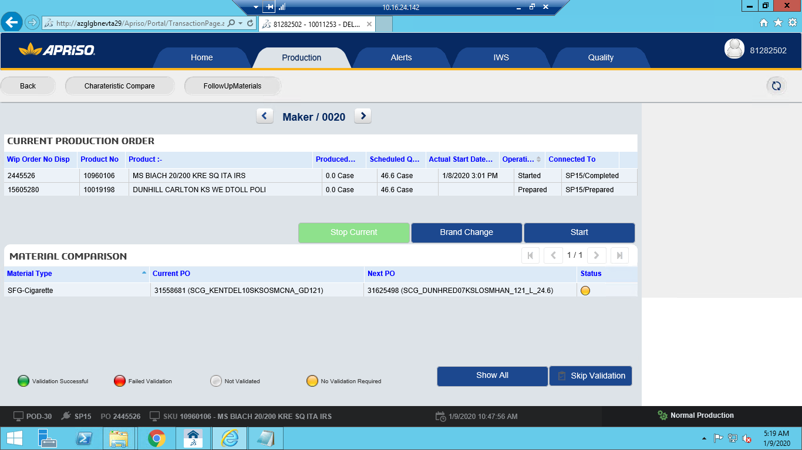

Click on "Stop Current" button 🡪

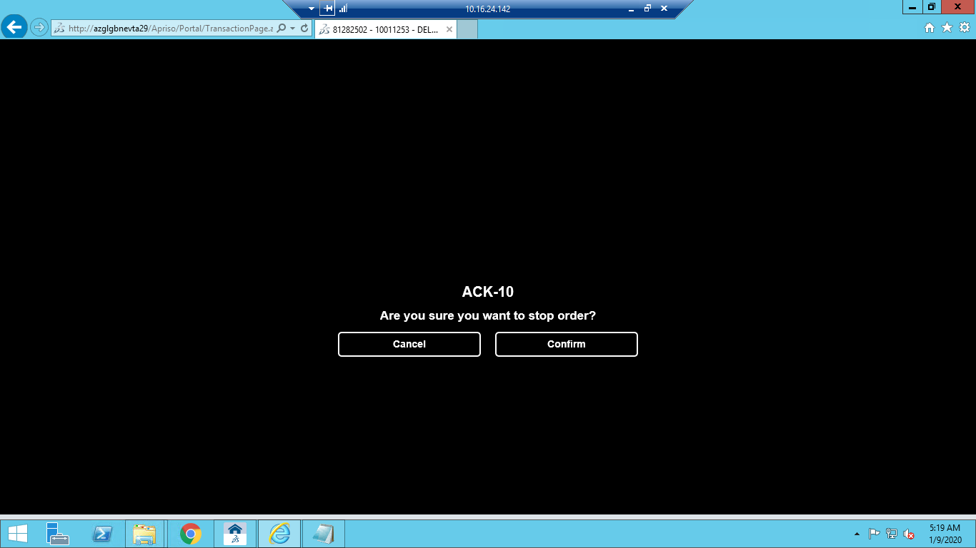

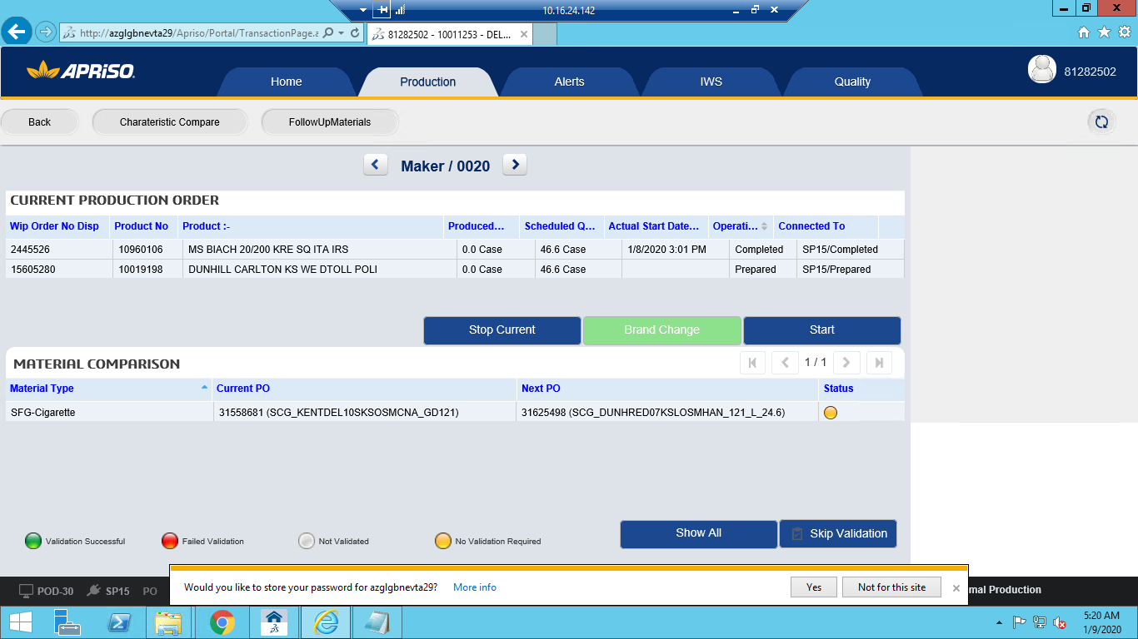

**Component 12 . ADM_JobHistory_MM_Check FSS Production Change Request**

12.1. Navigate to immediate job history(JE_IJH) using desktop client 🡪 Filter with 'TnTmessage' in Synchronization

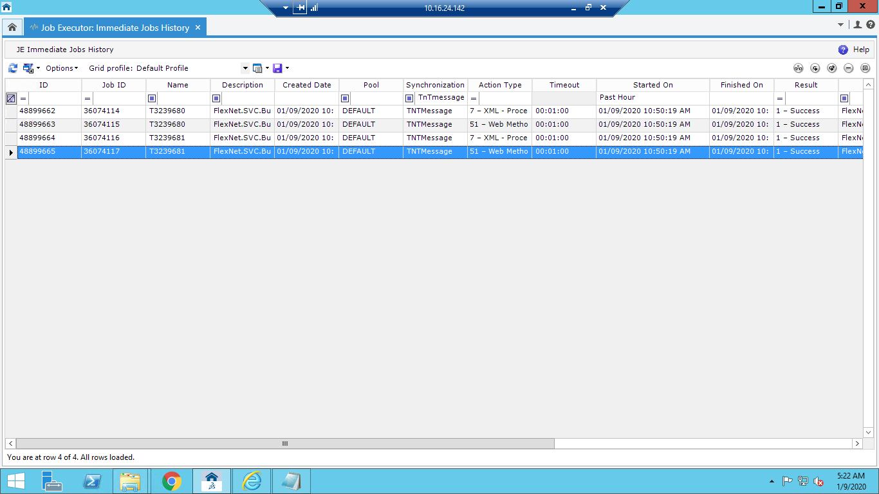

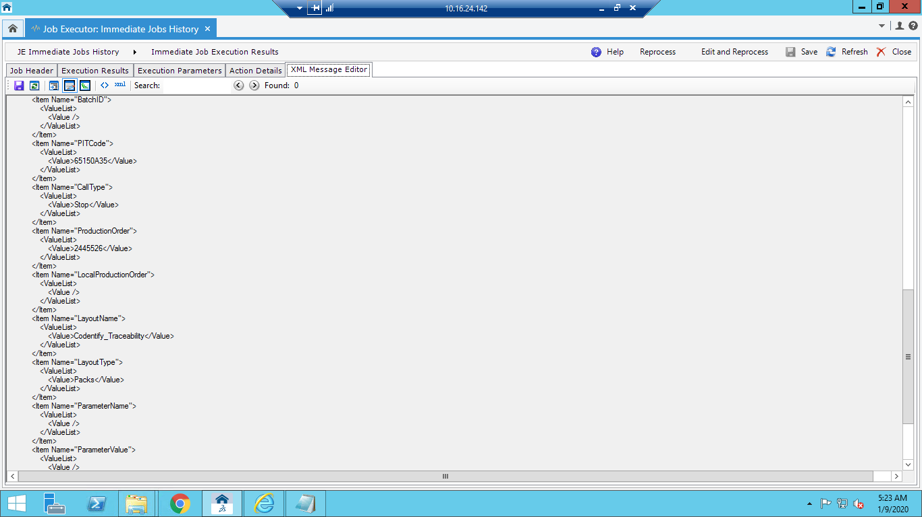

**Component 12. MFG_POD-30_OP_Brand Change Initiate**

Perform Brand change operation

**Component : ADM_JobHistory_MM_Check FSS Production Change Request**

Navigate to immediate job history(JE_IJH) using desktop client🡪 All TnT messages should be displayed

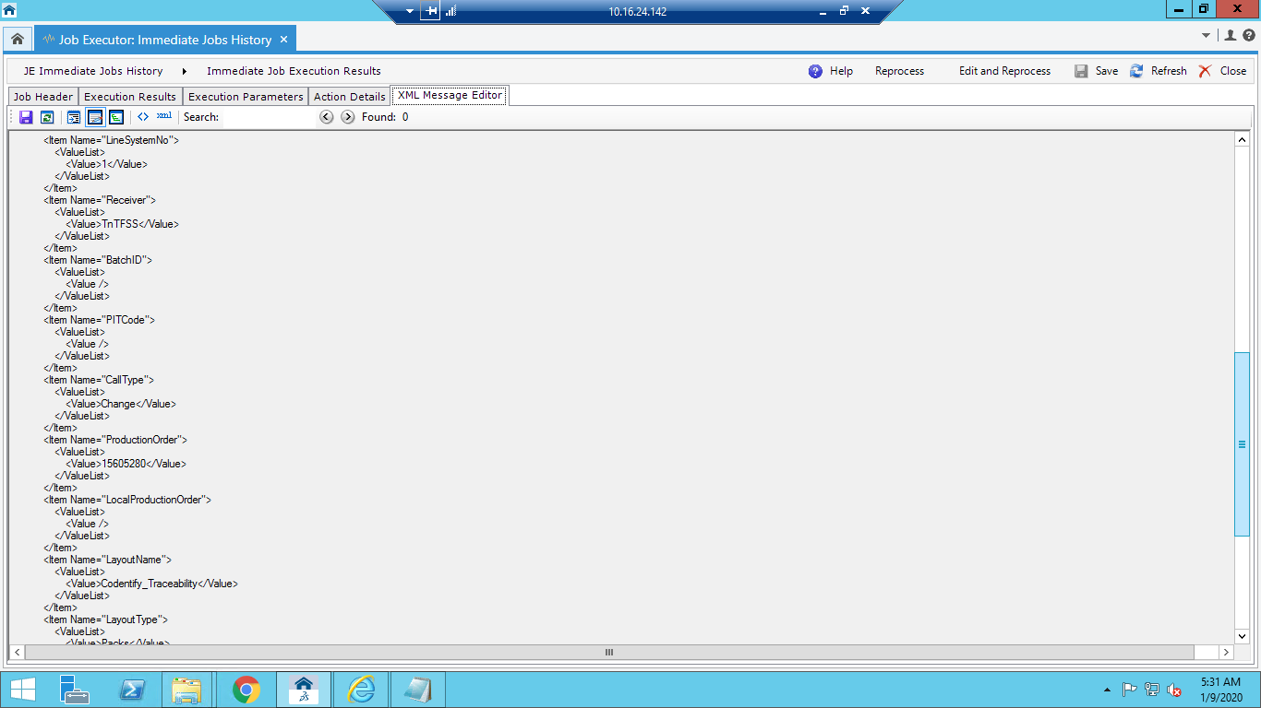

**Component: SMD_VSP-10_OP_View production order specification packer**

navigate to BAT Operations ->Operator Portal(UXOPP) -> Enter workcenter No and click on OK 🡪

Click on "Production" tab 🡪 Click on "Specification - Current PO" button 🡪

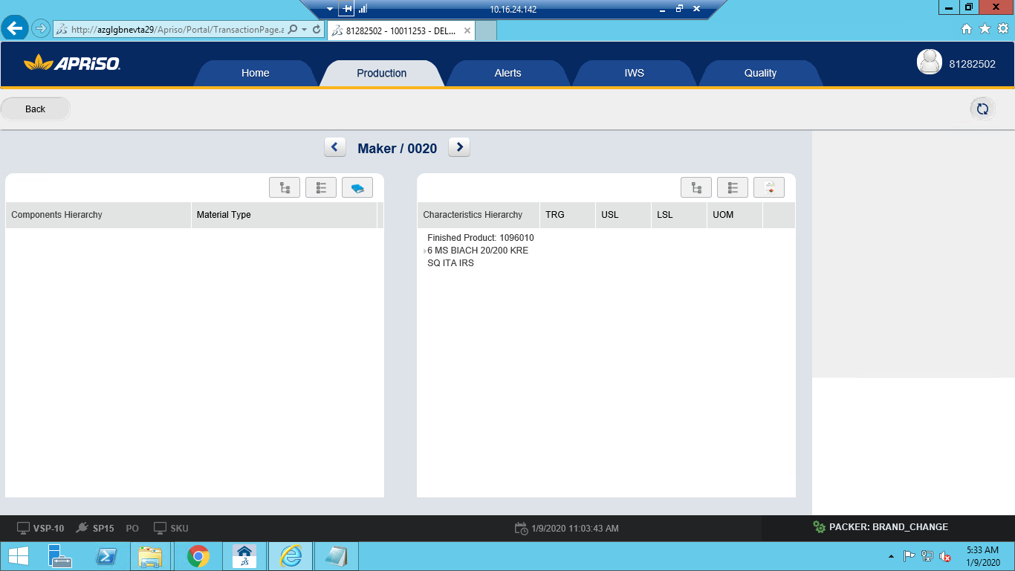

**Component: SMD_POD-70_OP_Send printing test data**

Apriso Desktop Client --> BAT Operations --> Desktop Operations --> Operator Portal(UXOPP) 🡪

Enter the workcenter which has working Po and click on ok 🡪 Click on the Production tab 🡪

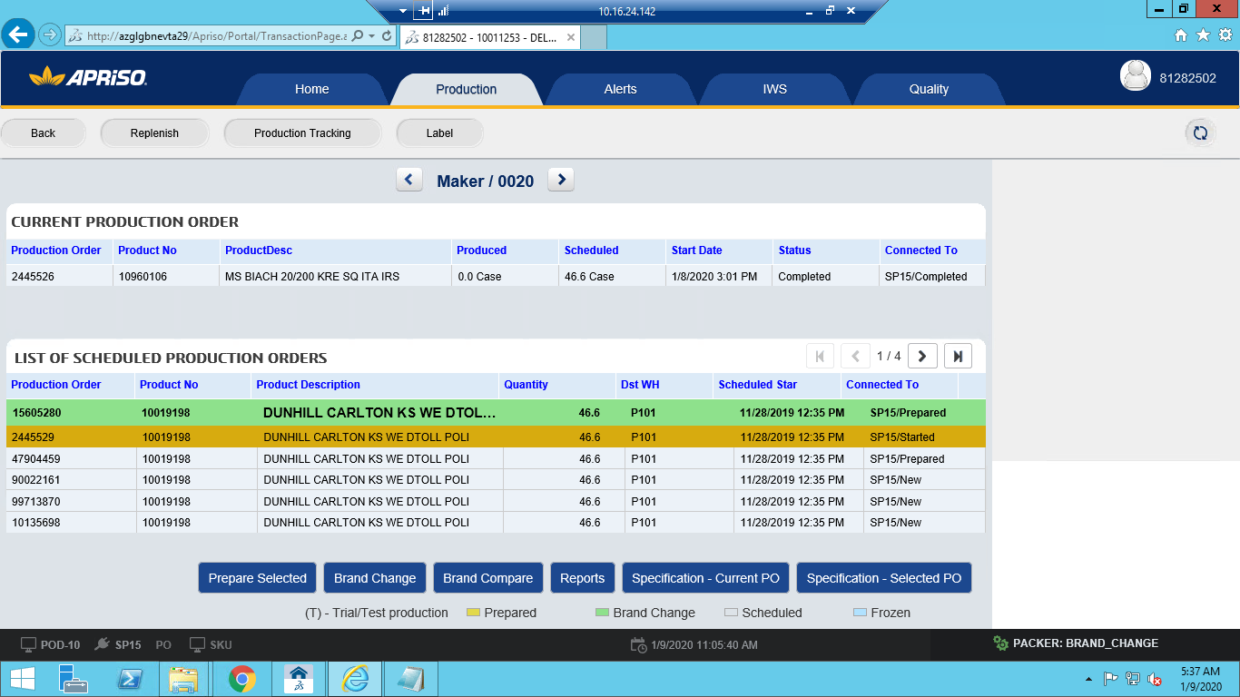

Click on the label button--Test Print 🡪

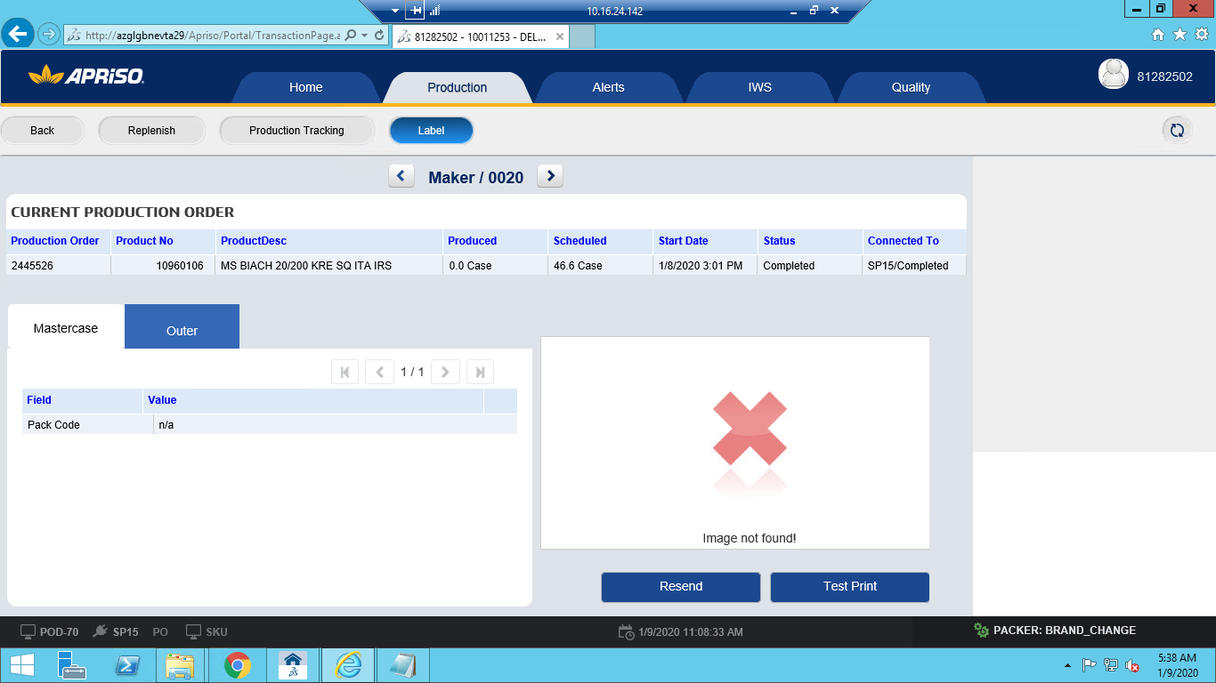

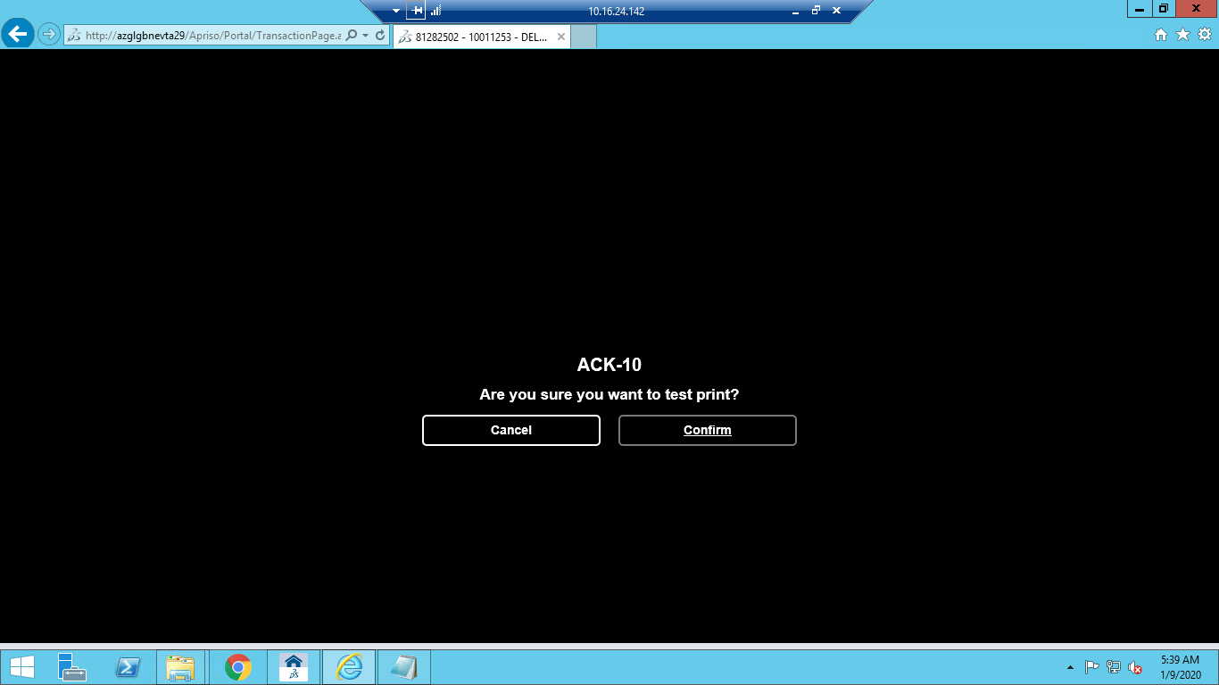

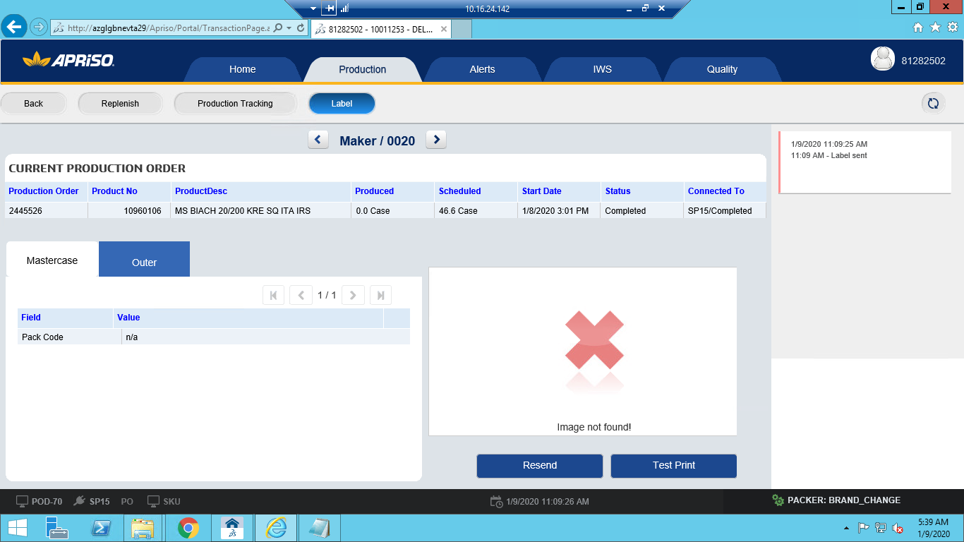

Navigate to immediate job history and verify the label print message 🡪

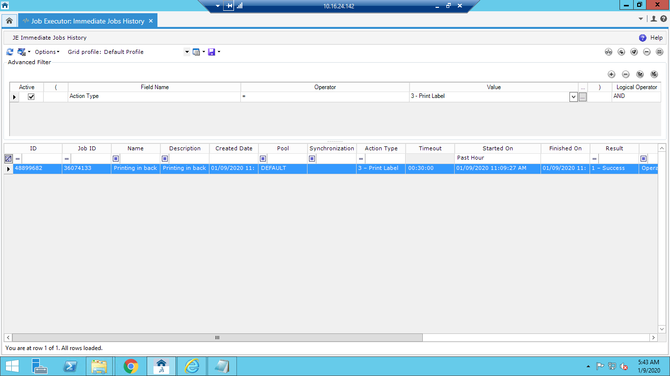

**Component: SMD_POD-30_OP_Start Production Order for packer**

navigate to BAT Operations -> UIUX Operations - > Operator Portal(UXOPP) -> Enter workcenter No and click on OK 🡪Click on "Production" tab 🡪Select a prepared PO (if same SKU) or a PO in brand change (if different SKU) and click on "Brand Change" button 🡪

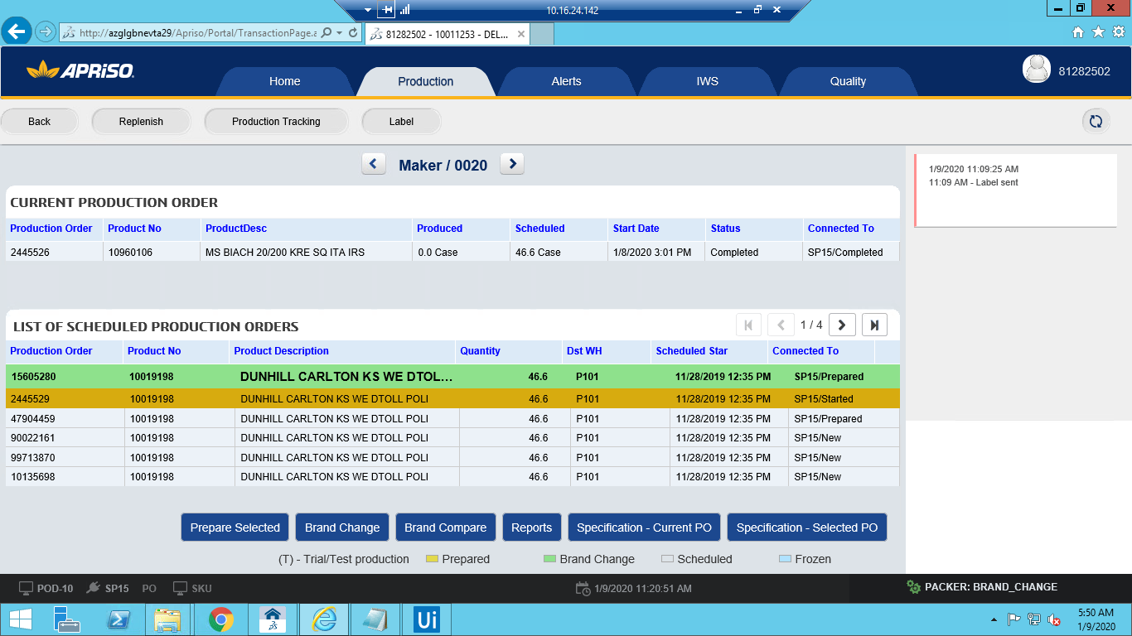

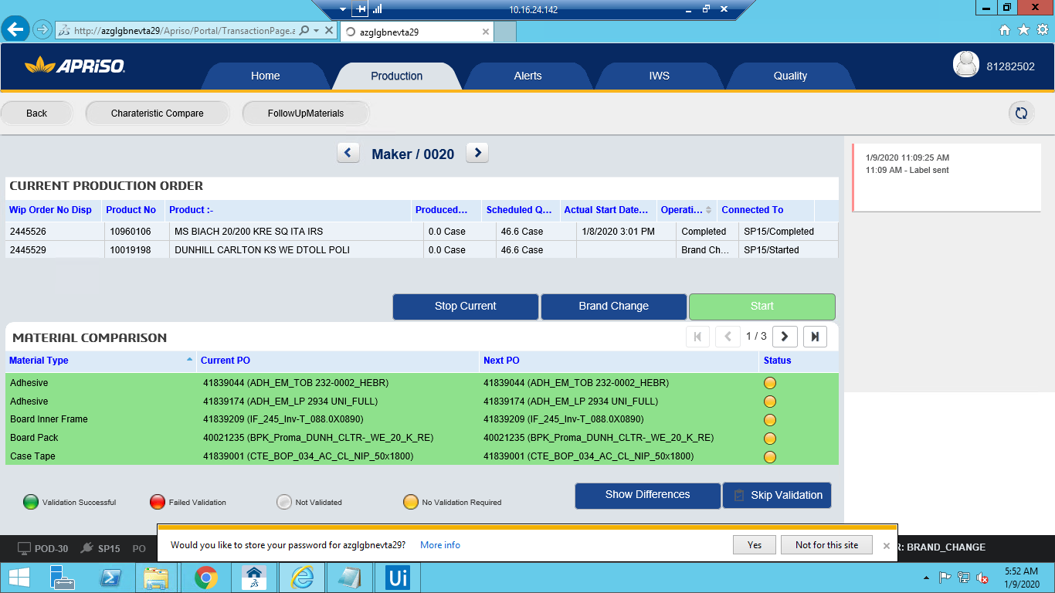

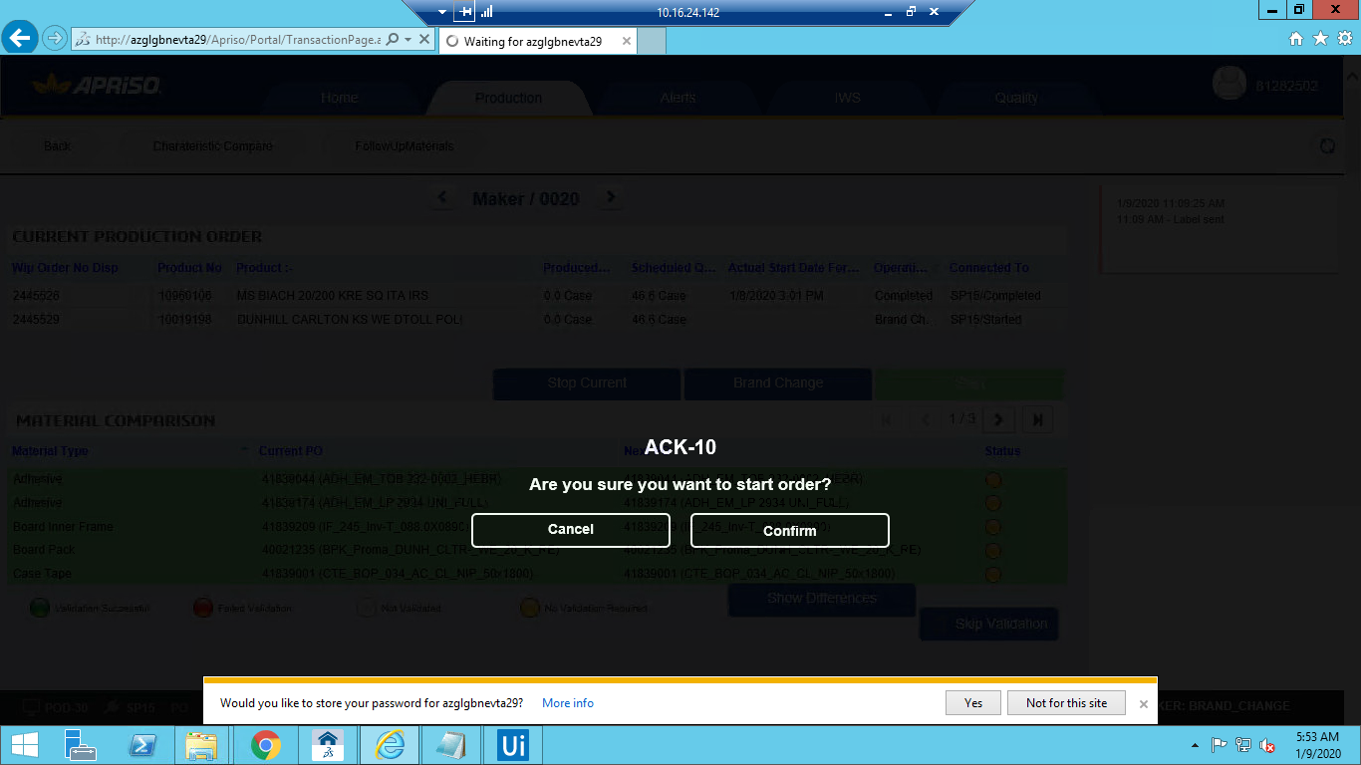

**12 Appendix**

